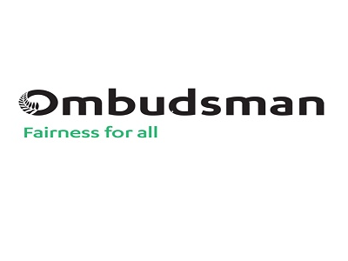

Information about an investigation into what the Ministry of Health does when someone who lives in a service for people with learning disability dies
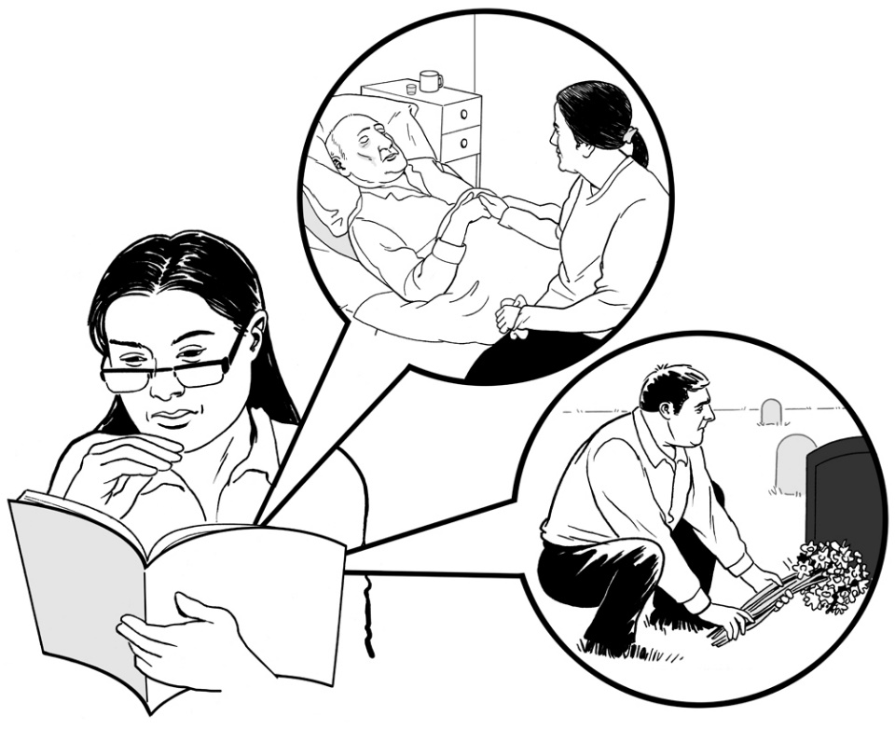

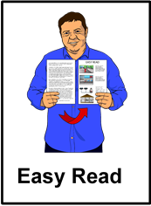

Before you read this
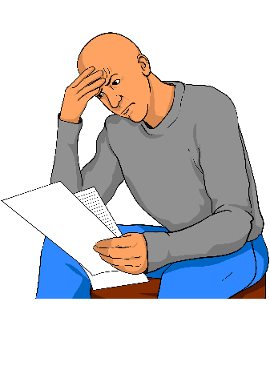
Some of the information in this document may make people upset when they are reading it.

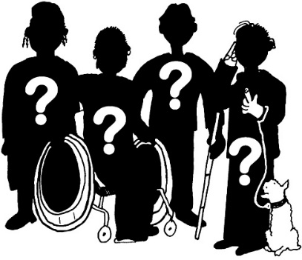
This information is:
- not meant to scare anyone

- not true for everyone with learning disability.

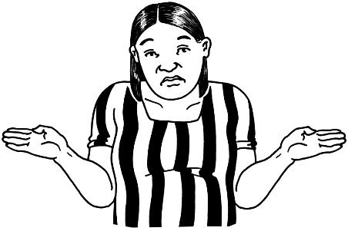
This information does not mean that these things will happen to you or someone you know.

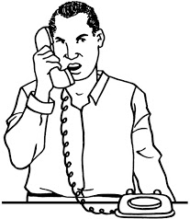
If you are worried after reading this document you can talk about it with:
- your family

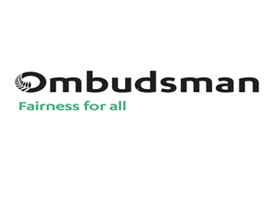
- your friends

- the Office of the Ombudsman on:

  - Phone: 0800 802 602

or
  - Phone: 04 473 9533

or

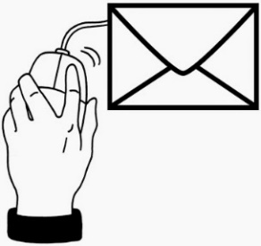
  - Email:
info@ombudsman.parliament.nz

What is in this book?

Page

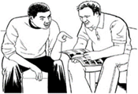
What is this book about? 5
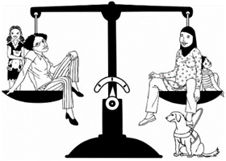
More about the Office of the Ombudsman 7
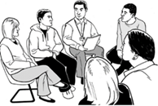
Who will do this investigation? 8

The Ministry of Health and the services 9
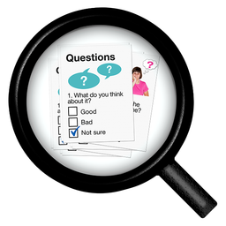
What does the team want to know? 11
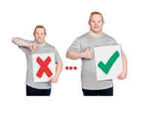
Why is the team doing this investigation? 13

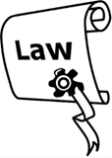
What does the law say about this
investigation? 15

Page

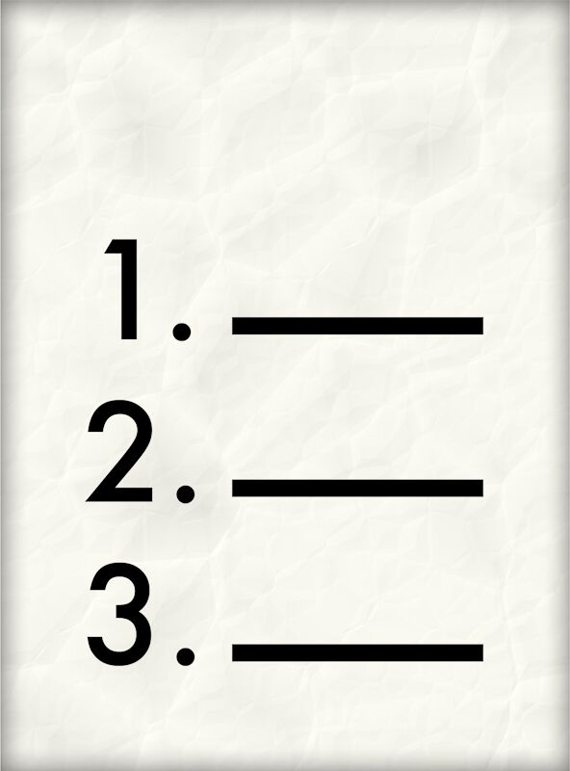
How will the team get the information they need? 17

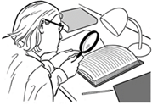
Which records will the team look at? 19
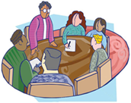
What will happen at the meetings with the Ministry of Health? 22
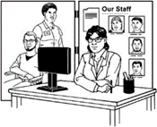
Talking to the services where people with learning disability live 24
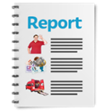
How will the team tell people what they
find out? 25
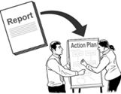
What happens after the investigation? 28

What is this book about?
The Office of the Ombudsman is going to do an investigation into the Ministry of Health.
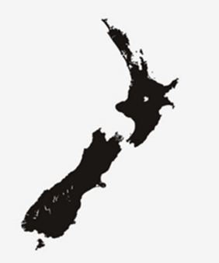
The Office of the Ombudsman looks at some of the places that work for the people of New Zealand.
Many of these places are government agencies like the Ministry of Health.
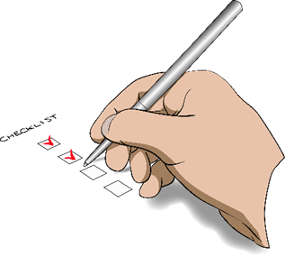
The Office of the Ombudsman makes sure that these places are:
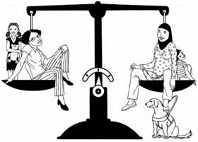
- working well

- treating people fairly.

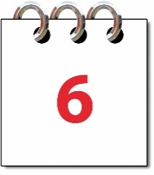
You can read more about the Office of the Ombudsman on page 7.
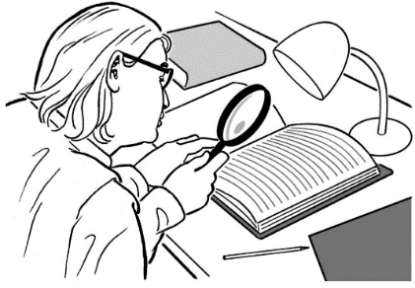
Doing an investigation means we will look closely at what the Ministry of Health is doing.

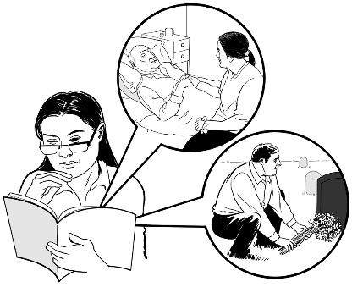
The Office of the Ombudsman will look closely to see what the Ministry of Health does when somebody who lives in a service for people with learning disability dies.

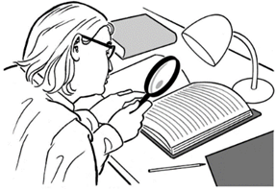
This book will tell you:
- what the investigation will look at
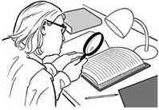
- what the investigation will not look at

- what will happen as part of the investigation.

More about the Office of the Ombudsman
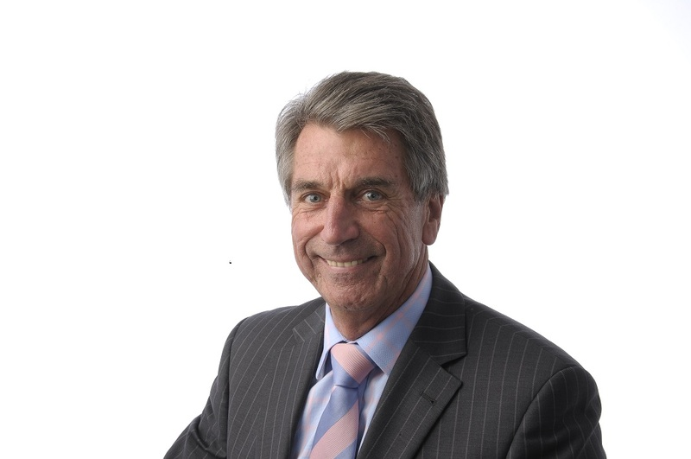
The Chief Ombudsman is Peter Boshier.
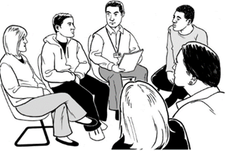
There are lots of people who work with him at the Office of the Ombudsman.

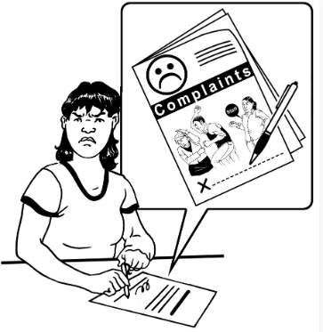
The Chief Ombudsman can ask the people who work with him to:
- look at complaints

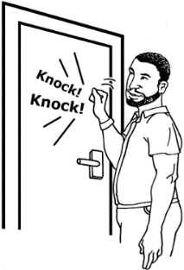
- do investigations

- check up on places like the services where people with learning disability live.

Who will do this investigation?
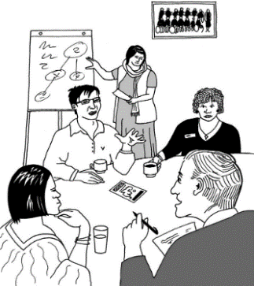
In this book the people from the Office of the Ombudsman who are doing the investigation will be called the team.

The people in the team are:
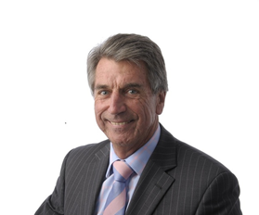
- The Chief Ombudsman

- a manager of the investigation called The Manager Systemic Improvement Investigations
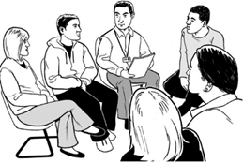
- a group of people from the Office of the Ombudsman who have done a lot of investigations.
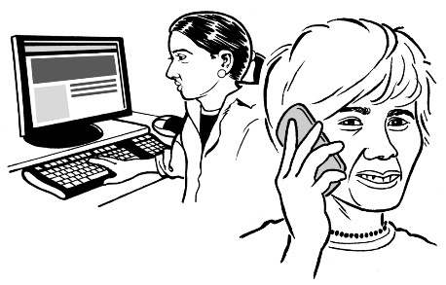
The Ministry of Health will choose a few of their people to keep in touch with the team.

The Ministry of Health and the services

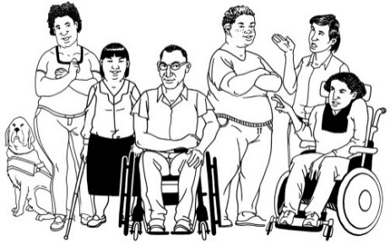
Some people with learning disability live in services that are run by different organisations.
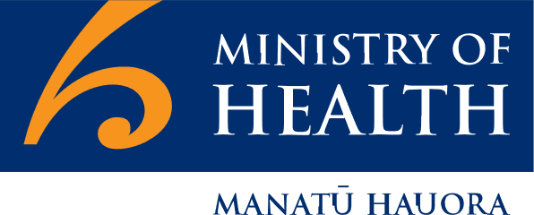
The Ministry of Health pays these organisations to run these services.
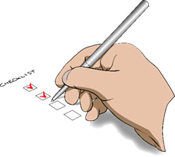
It is the job of the Ministry of Health to make sure that these services are running well.
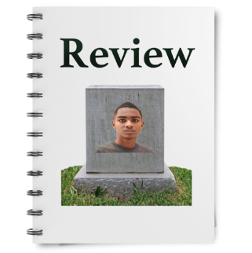
The Ministry of Health should keep records when people who live in the services die.

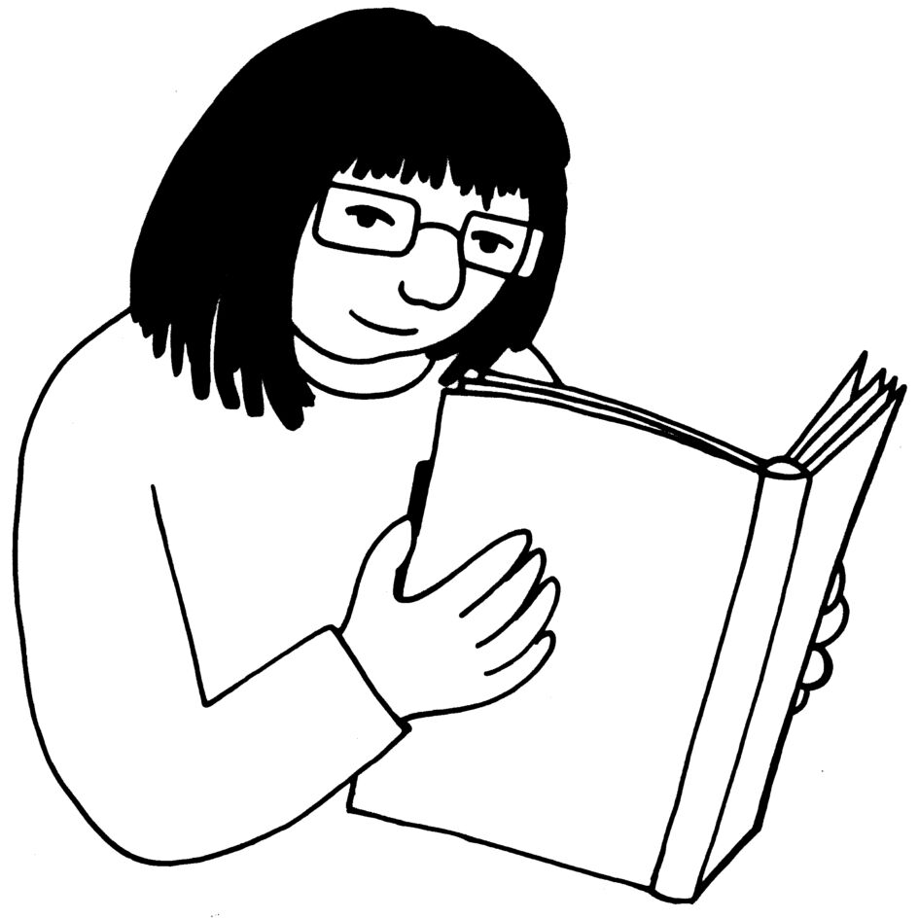
Keeping records means:
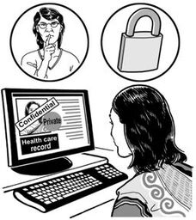
- writing down all the information you may need

- keeping the information safe
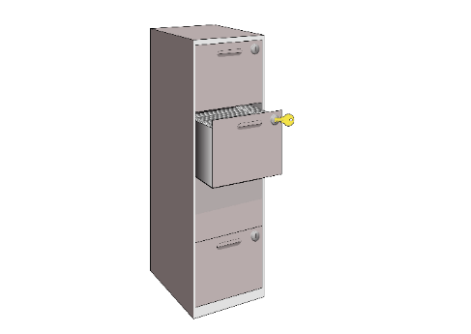
- knowing how to find the information when you need it.

What does the team want to know?

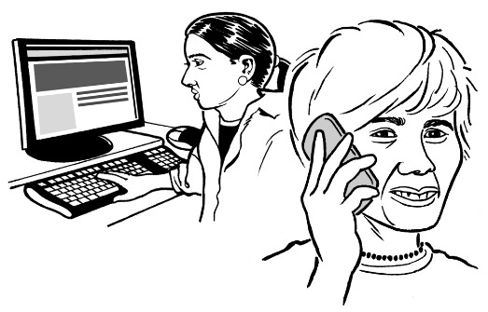
The team wants to know:
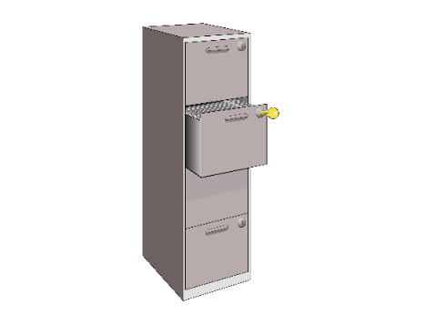
- How does the Ministry of Health get information about the deaths of people with learning disability?

- How does the Ministry of Health keep records about deaths?

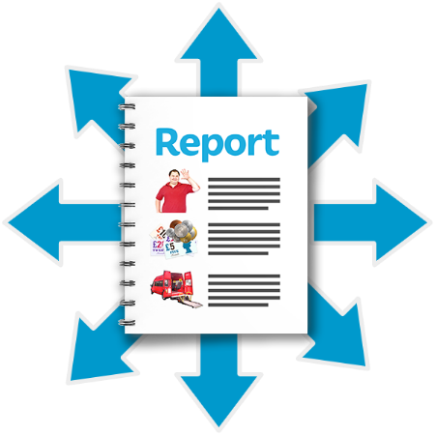
- How does the Ministry of Health tell people about the information that they have?

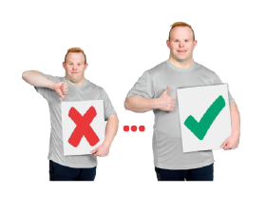
- What does the Ministry of Health do to make all the information they have easy to understand?

- Does the Ministry of Health use what they know to make services better?

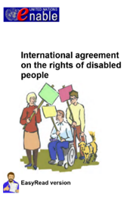
The team also wants to know if the Ministry of Health is following the rights set out in the United Nations Convention on the Rights of Persons with Disabilities.

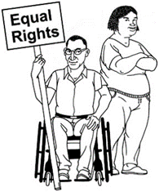
This is also known as the Disability Convention.

It says:
- how Disabled people should be treated
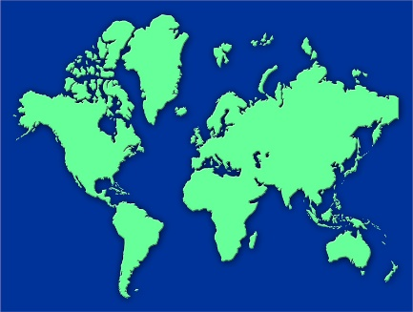
- what countries need to do to make sure Disabled people get their rights.

Why is the team doing this investigation?
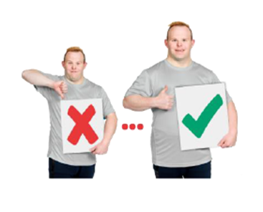
We are doing this investigation to see if we can help the Ministry of Health find better ways of doing their work.

The team will look to see if the Ministry of Health has ways of working that:
- are the same every time
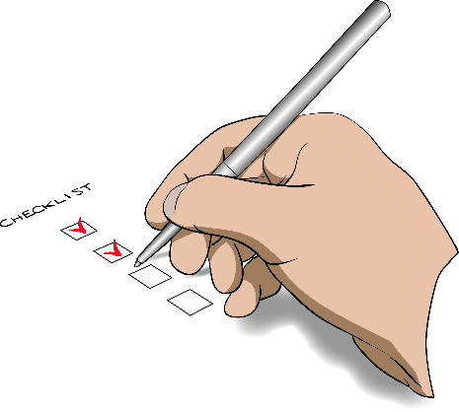
- make it easy to get the job done

- make it easy to see what has been done

- are easy for other people to understand.

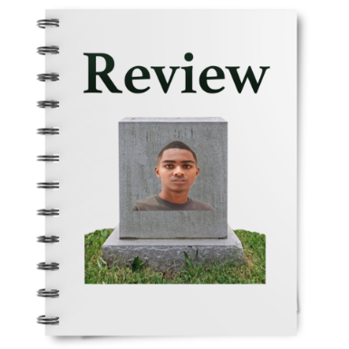
At the end of the investigation the team will make a report that says:
- what the Ministry of Health is doing well

- what the Ministry of Health might do better.

What does the law say about this investigation?
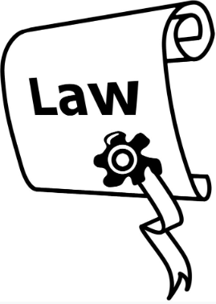
There are laws that will help the Investigation Team to:
- do their job

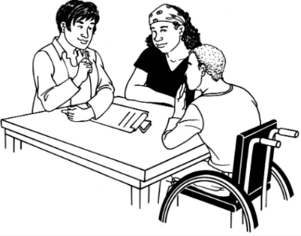
- get the information that they need.

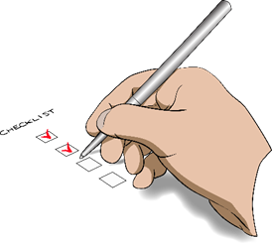
Law means a set of rules that the government makes that everyone must follow.

One of these laws is called the Ombudsmen Act 1975.

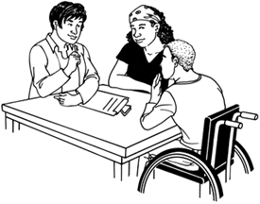
The Ombudsmen Act 1975 says:
- the team may ask any person to talk to them about the investigation
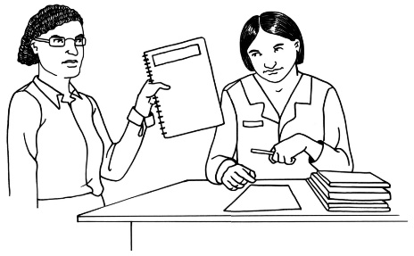
- if the team wants to look at paperwork it must be shown to them
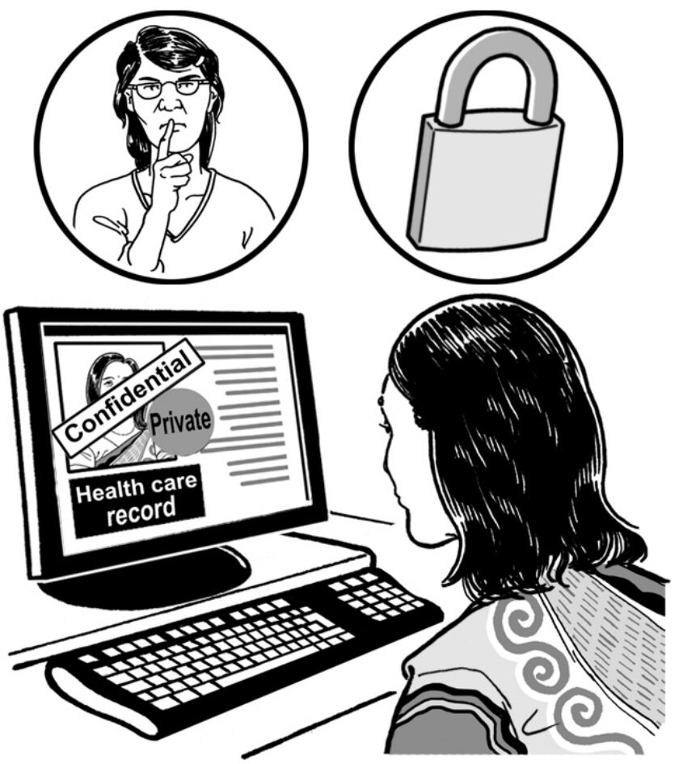
- the team must not talk about their report until the report is out for everyone to read.

- when they write the report they must only tell people what they need to tell them.

How will the team get the information they need?

To get the information they need the team will talk to:
- people from the Ministry of Health
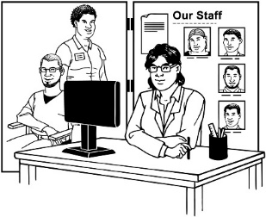
- people from the organisations that run services

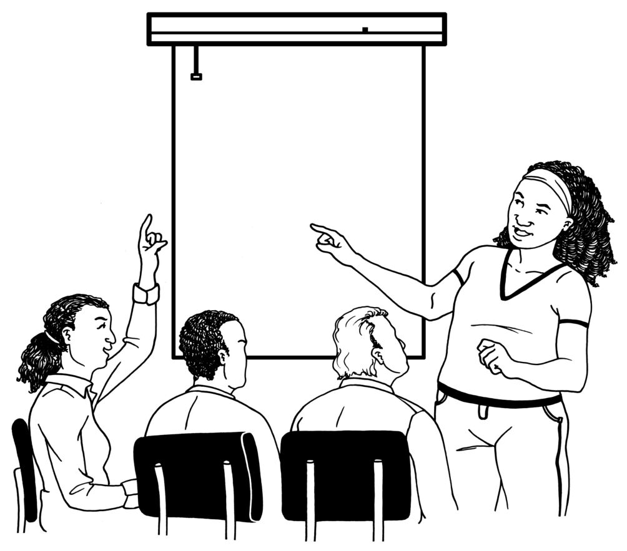
- someone who is not from the Ministry of Health who knows a lot about supporting people with learning disability.
The team will look at information that anyone can look at like the website of the Ministry of Health.

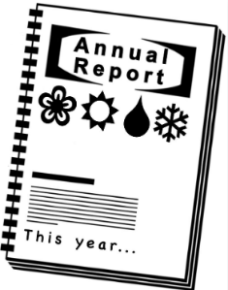
The team will also look at paperwork from the Ministry of Health like:
- the reports that the Ministry of Health do every year
- their plans for the next few years called strategic plans

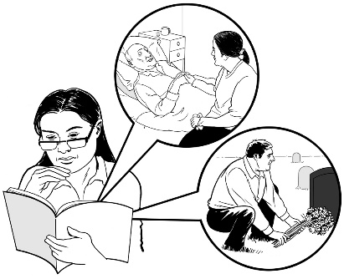
- the records about people who have died while they were living in a service.

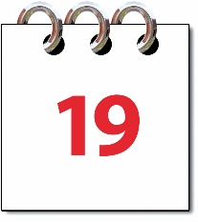
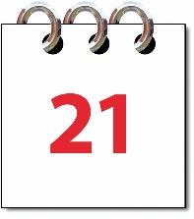
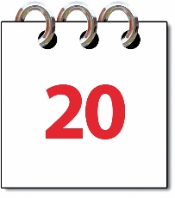
On pages 19 to 21 you can see:
- what records the team will look at

- what records the team will not look at.

Which records will the team look at?
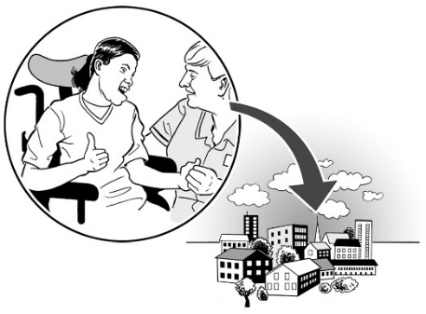
The team will look at the records the Ministry of Health has kept about people who have died in Community Residential Support Services.
Community Residential Support Services include:
- support in a place that is like a home

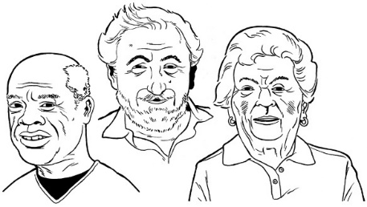
- services for older people that have people under 65 years old with learning disability living in them
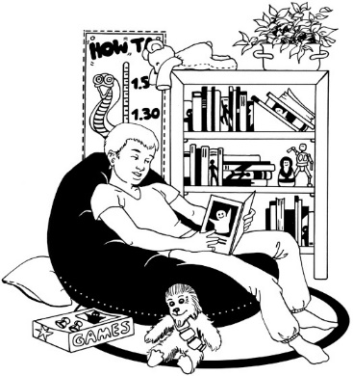
- support services where children and young people with learning disability live away from their families / whānau.
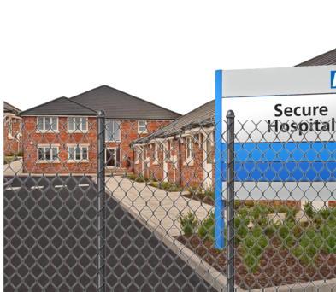
Some people with learning disability are under the High and Complex Framework.
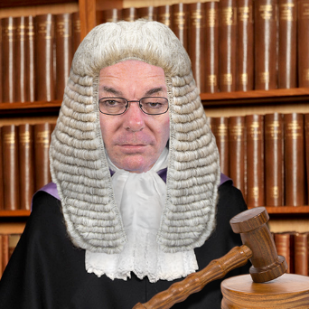
This means a judge has said that they have to live in a service.

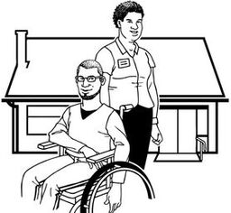
These people may live in one of these places:
- Regional Intellectual Disability Supported Accommodation Services (RIDSAS).

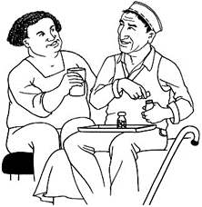
- Regional Intellectual Disability Secure Services (RIDSS).

- National Intellectual Disability Secure Services (NIDSS).

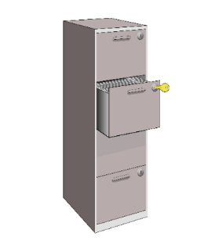
The team will look at the records the Ministry of Health has kept about the people who have died in these places too.
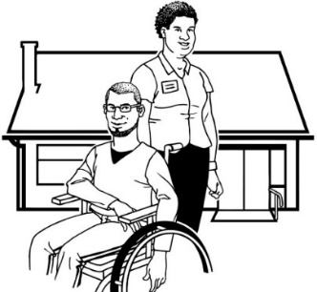
The team will not look at the records of deaths of people with learning disability who live in their own homes with support.
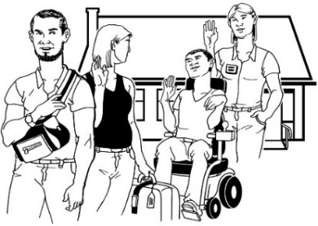
The team will not look at records of deaths that happen when someone stays at a service for a short time.
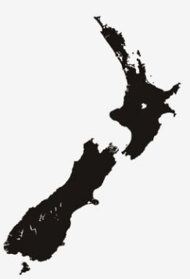
They will look closely at records from:
- Auckland
- Christchurch
- Wellington.
The team will look at records of deaths that happened in between January 2016 and 30 June 2018.

What will happen at the meetings with the Ministry of Health?

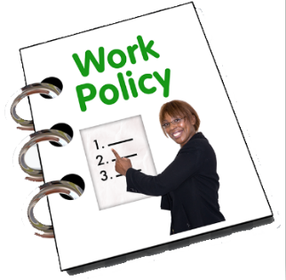
The team wants to talk to the people at the Ministry of Health who are in charge of things like:
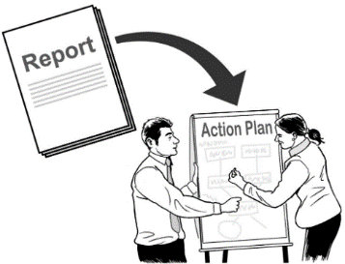
- how the Ministry of Health works with services where people with learning disability live

- what the Ministry of Health does when it hears that someone has died.
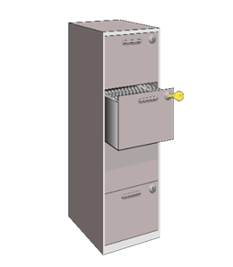
At the first meeting the Ministry of Health will show the team how they keep records.

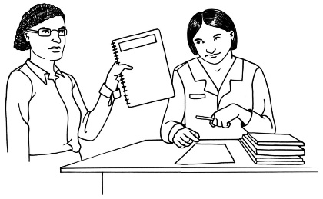
Then the team will tell the Ministry of Health what paperwork they want to look at.
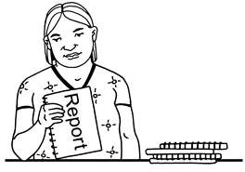
The team will look at all the paperwork.

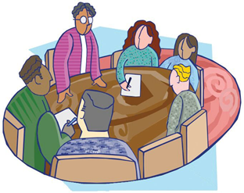
Then they may ask to have meetings with different groups of people at the Ministry of Health.
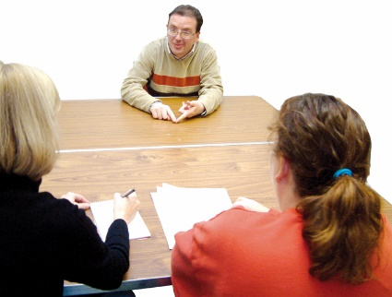
The team may also want to interview some people from the Ministry of Health.

Interview means the team will:
- talk to 1 person at a time

and

- ask them questions.

Talking to the services where people with learning disability live
The team will talk to the people who run the services where people with learning disability live.

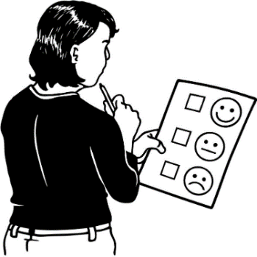
The team is not looking to decide if the people who run these services are doing a good job.

They just want more information to help them know if the Ministry of Health is doing a good job.

How will the team tell people what they find out?

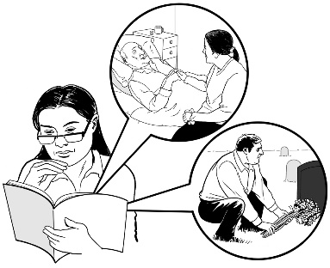
The team will write a draft report.

Draft means that there may be things they still need to change in the report.
They will give the draft report to the boss of the Ministry of Health.

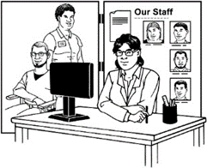
If the report says things about people who do not work at the Ministry of Health the team may show the draft report to those people too.

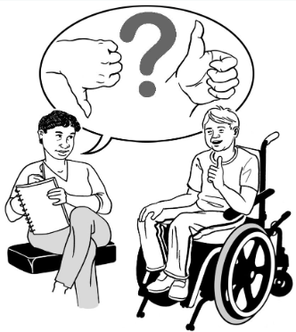
The people who have been shown the report can give feedback to the team if they are worried about parts of it.

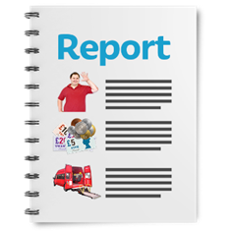
Feedback is where people can say what they think about the report.

The team may put feedback about the draft report into the final report.

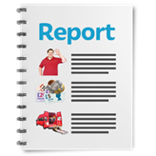
It is called the final report when there are no more changes to be made.

The final report will go to:
- the boss of the Ministry of Health
- the website of the Ombudsman where everyone can read it

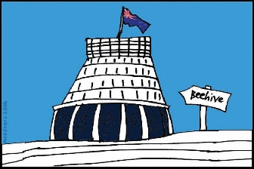
- Parliament for them to talk about.

Parliament is where the Prime Minister and other people who run the country work.
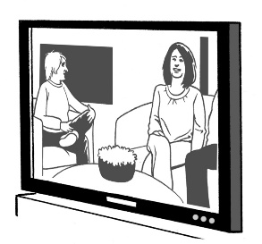
The report might be talked about on:
- TV and radio stations

- Newspapers

- news organisations on the internet.

What happens after the investigation?

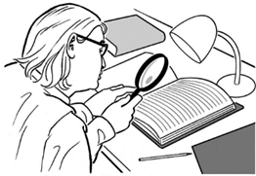
The Ombudsman will keep looking at how the Ministry of Health is keeping records.
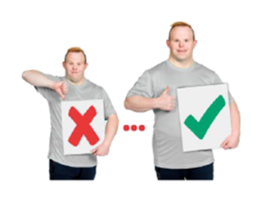
The Ombudsman will look to see if the Ministry of Health is making changes.

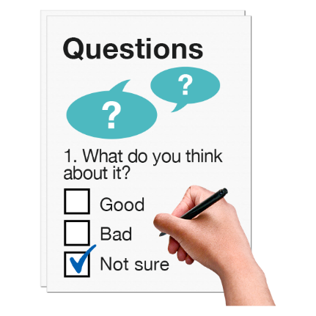
The Ombudsman will ask the Ministry of Health:
- what did the investigation team do well?

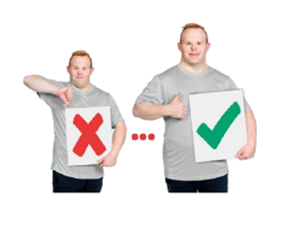
- what can the team do better next time?

- will this investigation help you work better in future?

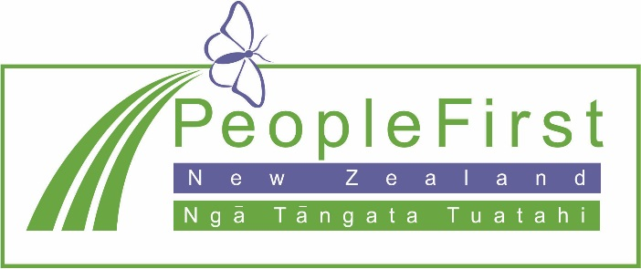

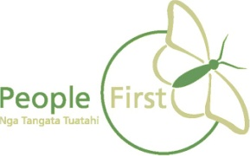
This information has been translated into Easy Read by the Make It Easy service of People First New Zealand Inc. Ngā Tāngata Tuatahi.

The ideas in this document are not the ideas of People First New Zealand Ngā Tāngata Tuatahi.
