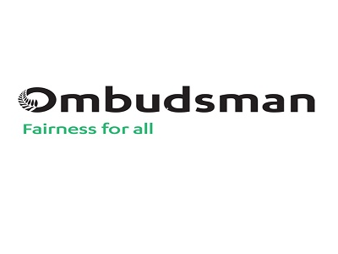

Information about an investigation into how the Ministry of Health helps to look after people with learning disability who are in secure care.
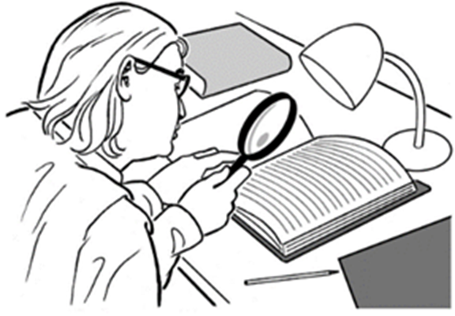

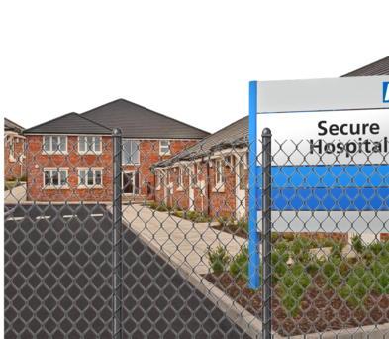

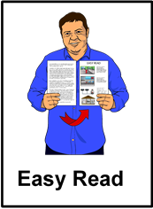

Before you read this
Some of the information in this document may make people upset when they are reading it.

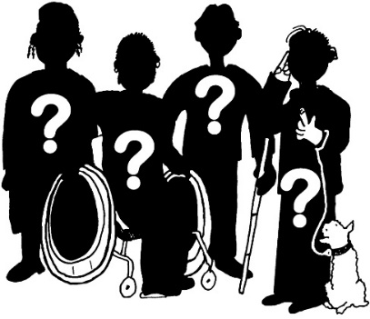
This information is:
- not meant to scare anyone

- not true for everyone with learning disability.

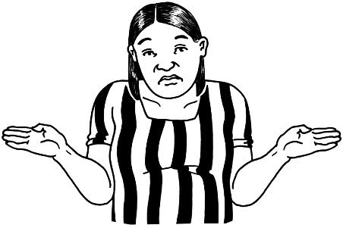
This information does not mean that these things will happen to you or someone you know.

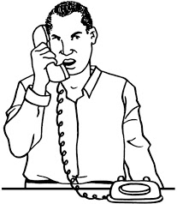
If you are worried after reading this document you can talk about it with:
- your family

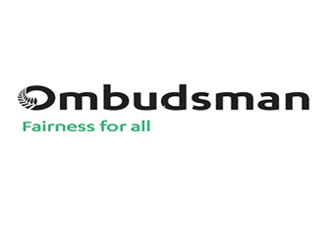
- your friends

- the Office of the Ombudsman on:

  - Phone: 0800 802 602

or
  - Phone: 04 473 9533

or

  - Email:
info@ombudsman.parliament.nz

What is in this book?

Page
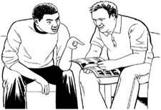
What is this book about? 5
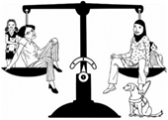
More about the Office of the Ombudsman 8
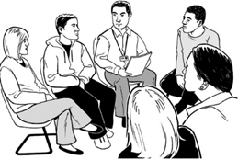
Who will do this investigation? 9
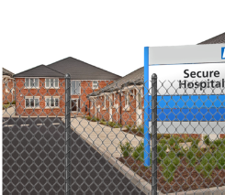
What is the High and Complex
Framework? 11
High and Complex Framework
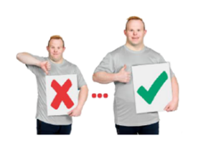
services and the Ministry of Health 14

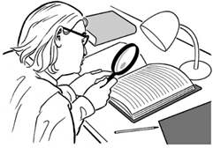
Why is the team doing this investigation? 16
What will the team look at? 20

Page

Case studies 22
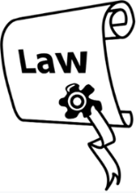
What does the law say about this
investigation? 24
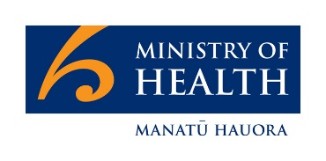
Talking to the Ministry of Health 26
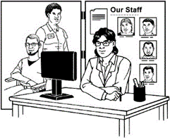
Talking to people from the High and
Complex Framework services 29
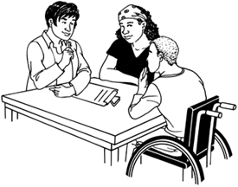
Who else will the team talk to? 31
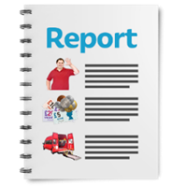
How will the team tell people what they
find out? 32
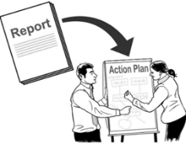
What happens after the investigation? 35

What is this book about?
The Office of the Ombudsman is going to do an investigation into the Ministry of Health.
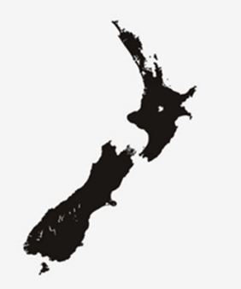
The Office of the Ombudsman looks at some of the places that work for the people of New Zealand.
Many of these places are government agencies like the Ministry of Health.
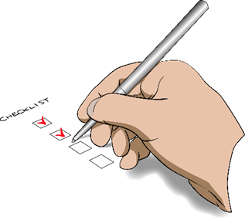
The Office of the Ombudsman makes sure that these places are:
- working well
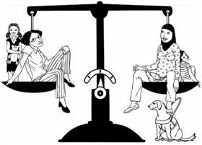
- treating people fairly.

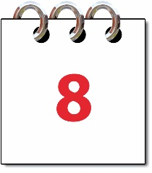
You can read more about the Office of the Ombudsman on page 8.
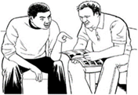
This book is about the investigation we are going to do.

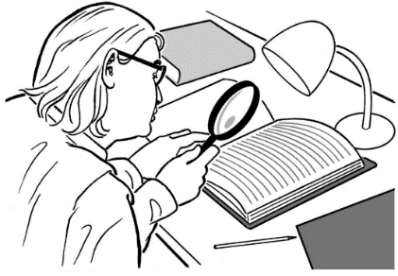
Doing an investigation means we will look closely at what the Ministry of Health is doing.

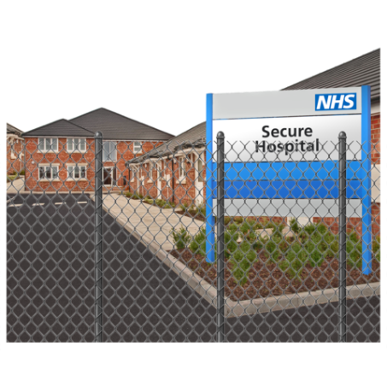
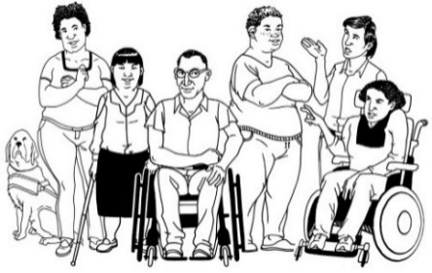
The Office of the Ombudsman wants to know how the Ministry of Health helps look after services for people with learning disability.

In this investigation we will look at the services for people who are under the High and Complex Framework.
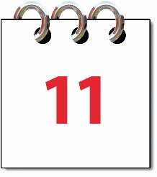
You can read about the High and Complex Framework on page 11.

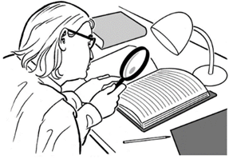
This book will tell you:
- what the investigation will look at
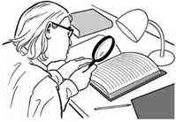
- what the investigation will not look at
- what will happen as part of the investigation.

More about the Office of the Ombudsman
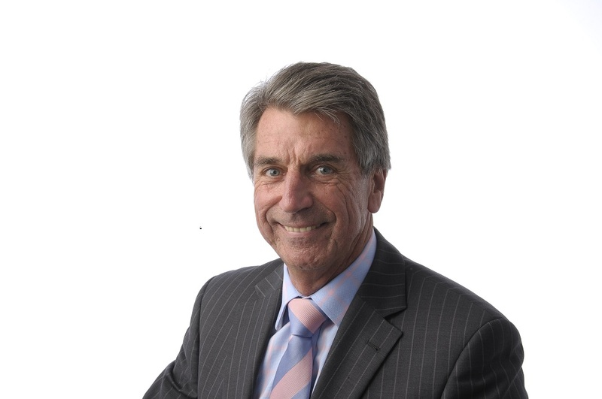
The Chief Ombudsman is Peter Boshier.
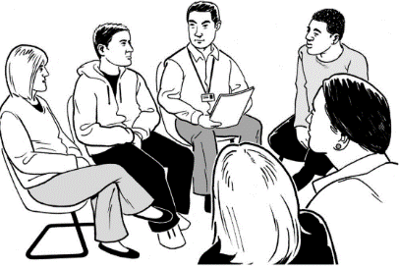
There are a lot of people who work with him at the Office of the Ombudsman.

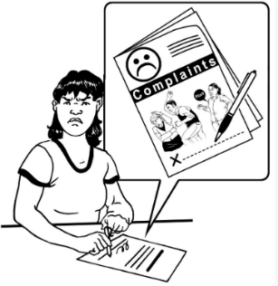
The Chief Ombudsman can ask the people who work with him to:
- look at complaints

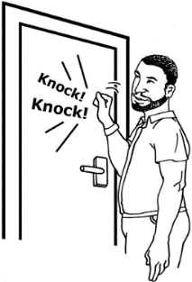
- do investigations

- visit places like the High and Complex Framework services to check up on them.

Who will do this investigation?
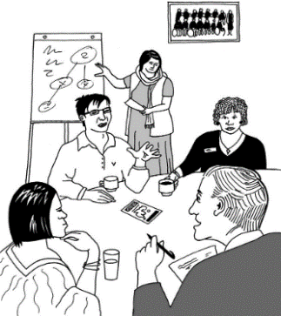
People who work at the Office of the Ombudsman will be doing the investigation.

In this book these people will be called the team.
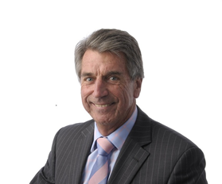
The people in the team are:
- the Chief Ombudsman

- a manager of the investigation called the Manager Systemic Improvement Investigations

- a group of people from the Office of the Ombudsman who have done a lot of investigations.

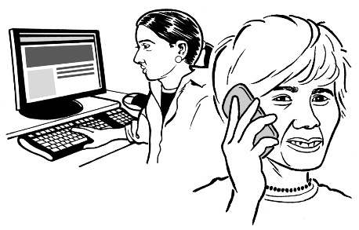
The Ministry of Health will choose a few of their people to keep in touch with the team.

What is the High and Complex Framework?
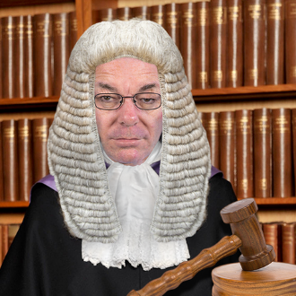
Some people with learning disability have compulsory care orders.

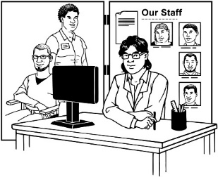
A compulsory care order means that a judge has said that a person must:
- live at a service for people with learning disability

- follow the rules of that service.
The High and Complex Framework is the name for this group of services.

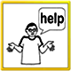
These services can also be used by other people who have needs that cannot be met anywhere else.

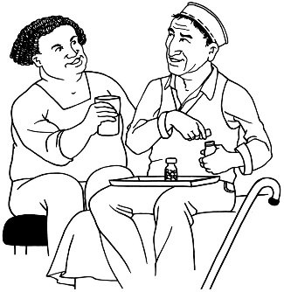
The services that are part of the High and Complex Framework give a lot of support to the people who live there.

They are also secure.

This means that the people who live there cannot leave if they want to.

These are some of the services that are part of the High and Complex Framework:

- the Pohutukawa Unit in Auckland

- the Henry Rongomau Bennett Centre in Hamilton

- the Haumietiketike Unit in Wellington

- Hikitia Te Wairua for young people in Wellington

- 2 cottages for people who are moving back to the community in Wellington

- Hillmorton Hospital in Christchurch

- Wakari Hospital in Dunedin

- Helensburgh cottage in Dunedin.

High and Complex Framework services and the Ministry of Health

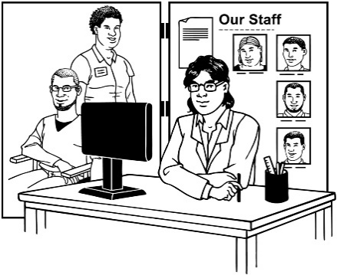
Every service that is part of the High and Complex Framework has a DHB that looks after it.

The full name for DHB is District Health Board.

A DHB looks after all the health services in its part of the country.
The Ministry of Health gives money to DHBs for the services that are part of the High and Complex Framework.
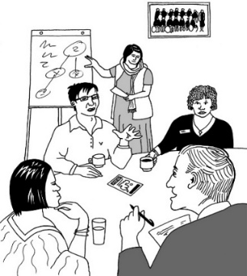
The Ministry of Health and the DHBs work together to look after the services.

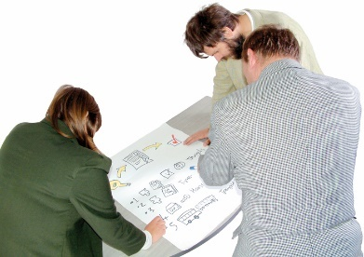
These are some things that it is the job of the Ministry of Health to do:
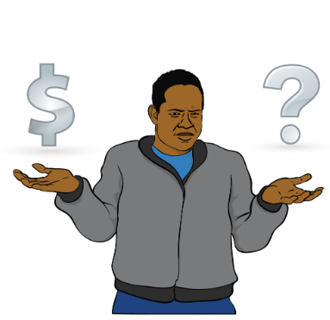
- make plans for the future of the services that are part of the High and Complex Framework

- make sure these services have what they need to run well

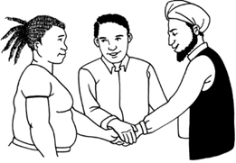
- help the services that are part of the High and Complex Framework to work with other services.

Why is the team doing this investigation?

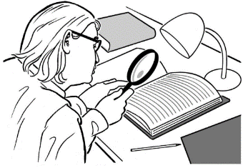
We are doing this investigation to:
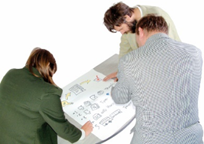
- see how the Ministry of Health looks after the services that are part of the High and Complex Framework

- help the Ministry of Health find better ways to do their work
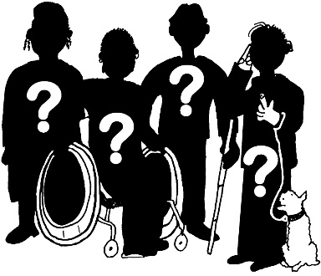
- find out what life is like for people who use these services
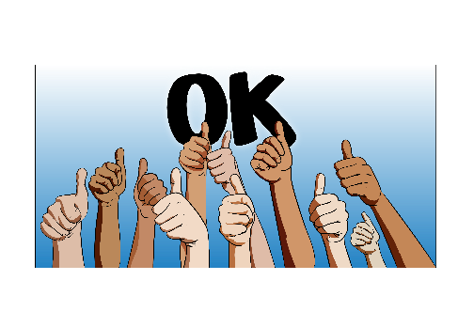
- find areas where the Ministry of Health is doing a good job.

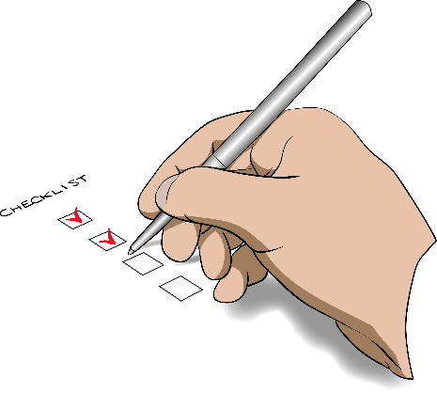
The Office of the Ombudsman wants to know if the Ministry of Health has ways of working that:
- are fair for all people

- make it easy to get the job done

- make it easy to see what has been done.

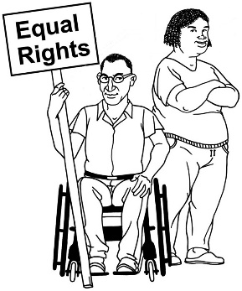
We also want to know if the Ministry of Health is following the rights set out in:
- the United Nations Convention on the Rights of Persons with Disabilities.

- the United Nations Convention on the Rights of the Child.

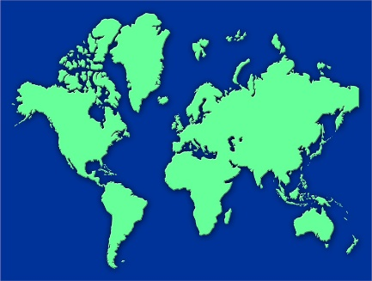
These are agreements between countries that say how people should be treated.

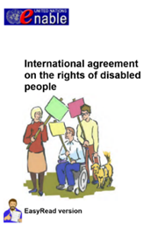
The United Nations Convention on the Rights of Persons with Disabilities is also known as the Disability Convention.

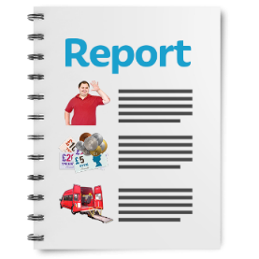
At the end of the investigation the team will make a report that says:
- what the Ministry of Health is doing well
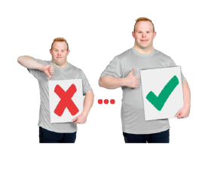
- what the Ministry of Health might do better.

What will the team look at?
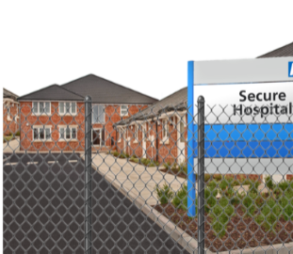
The team will look at the High and Complex Framework services to see if they have enough space for all the people who need this kind of support.
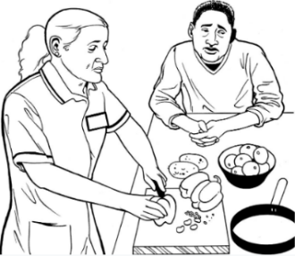
They will also look to see if the services do a good job for all the people who live there like:
- people with lots of needs who will stay there a long time

- women
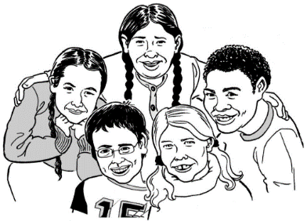
- young people.

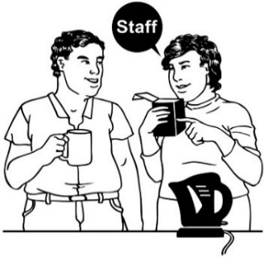
The team will also look to see if there are enough people with the right training to work in these services.

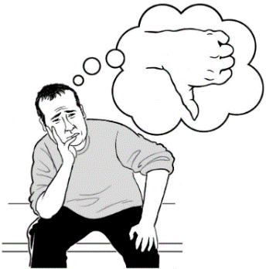
The team will look at what the Ministry of Health does when there is a problem in these services.

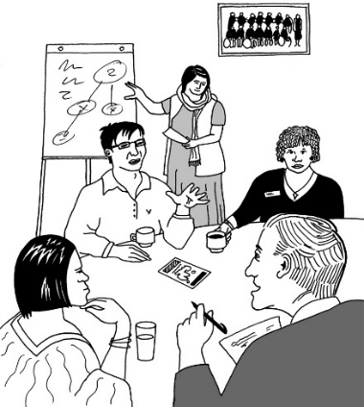
They want to know how the Ministry of Health:
- works with DHBs to fix problems

- does its part to look after the services.
The investigation will mostly look at services that are part of the High and Complex Framework.
But it will also look at how the High and Complex Framework services work with other services.

The investigation will mostly look at things that have happened since January 2013.

Case studies

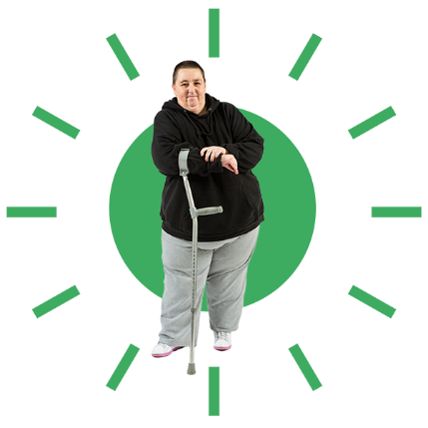
The team will do case studies to help them understand if services are working well.

Case studies are where the team will look closely at what has happened to real people.

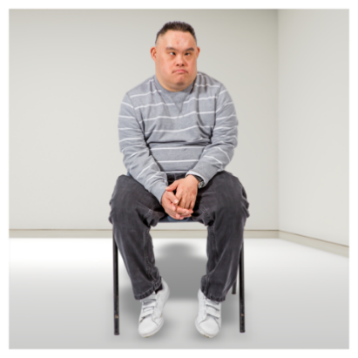
This is how the case studies will work:
- The team will choose some people with learning disability who are living under the High and Complex Framework.

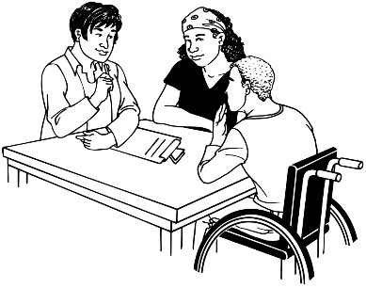
- The team will talk to the people with learning disability who they have chosen.

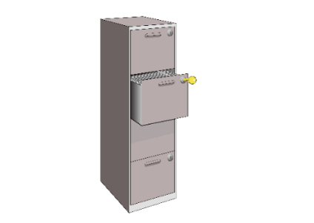
- For each person they will look closely at information to see how they have been treated.

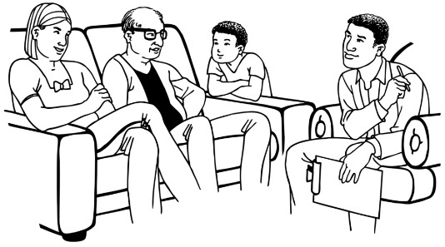
- They might also talk to their family / whānau.

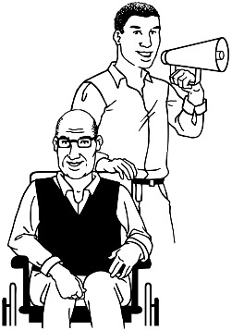
- If the people with learning disability want someone else to speak for them the team will try to talk to those people too.

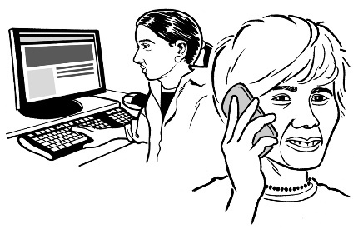
The team will get in touch with people by talking to the services where they live.

What does the law say about this investigation?
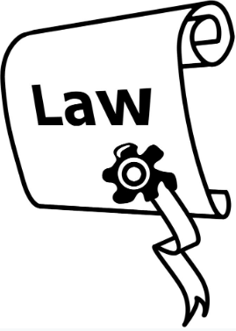
There are laws that will help the Investigation team to:
- do their job

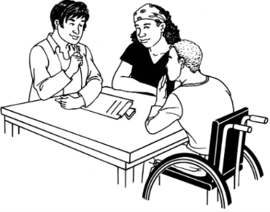
- get the information that they need.

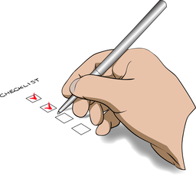
Law means a set of rules that the government makes that everyone must follow.

One of these laws is called the Ombudsmen Act 1975.

The Ombudsmen Act 1975 says:
- the team may ask any person to talk to them about the investigation
- if the team wants to look at paperwork it must be given to them
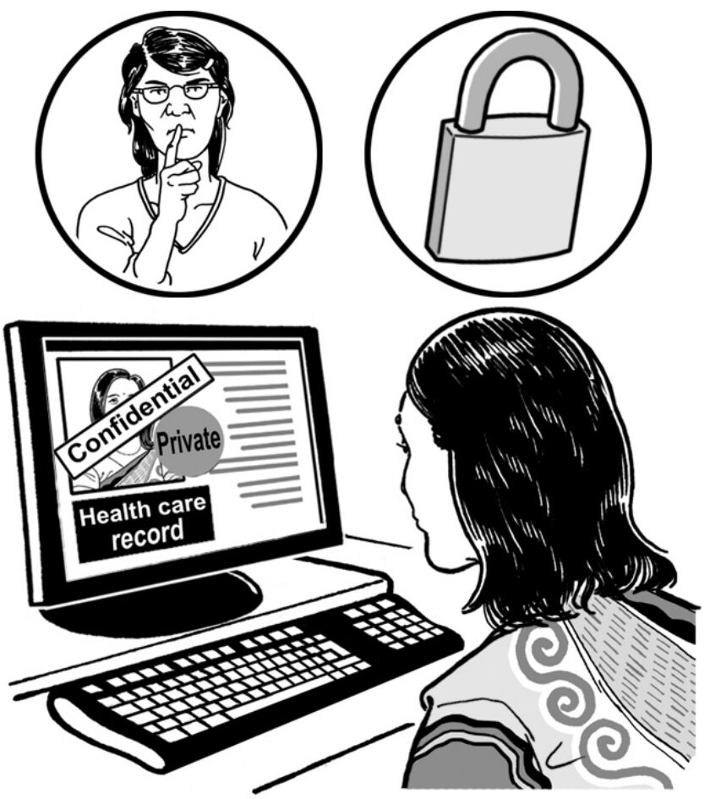
- the team must not talk about their report until the report is out for everyone to read

- when the team write the report they must only tell people what they need to tell them.

Talking to the Ministry of Health
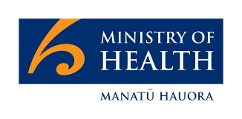
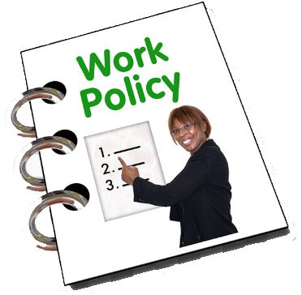
The team want to talk to people from the Ministry of Health who are in charge of things like:
- deciding how the Ministry of Health does their work
- making sure the High and Complex Framework is running well.
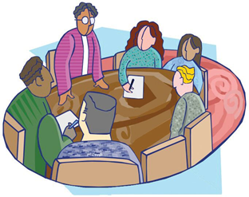
At the first meeting the Ministry of Health will show the team what kind of useful information they have.
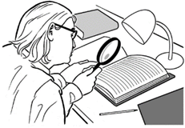
The team will tell the Ministry of Health:
- what the investigation will look at

- how they will do case studies.
After this meeting the team will tell the Ministry of Health what paperwork they want to look at.

This will include paperwork about:
- case studies

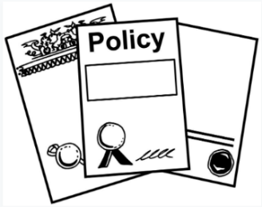
- how the Ministry of Health does its work

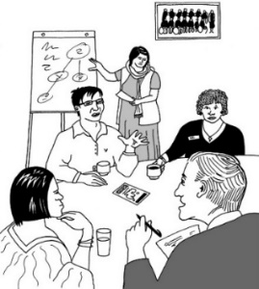
- how the Ministry of Health works with

  - services

  - DHBs
- what the Ministry of Health does when there is a problem.

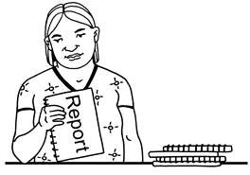
The team will look at all of the paperwork.
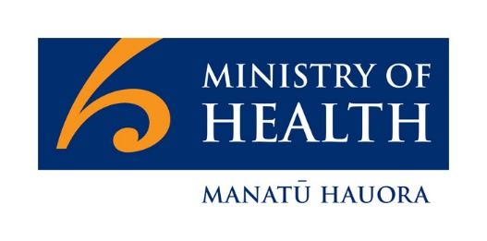
Then they may ask to have meetings with different groups of people at the Ministry of Health.

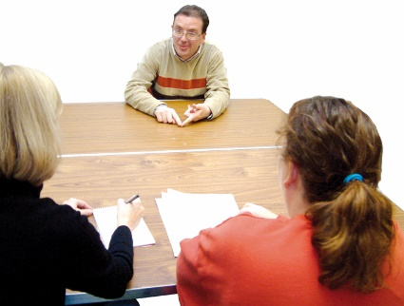
The team may also want to interview some people from the Ministry of Health.

Interview means the team will:
- talk to 1 person at a time

and

- ask them questions.

Talking to people from the High and Complex Framework services

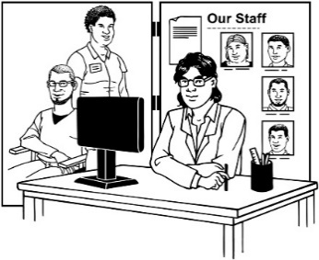
The team will talk to the people who run the High and Complex Framework services.

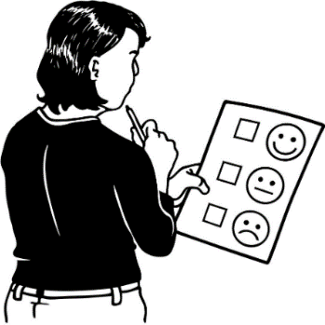
The team is not looking to decide if the people who run those services are doing a good job.

They just want more information to help them know if the Ministry of Health is doing a good job.

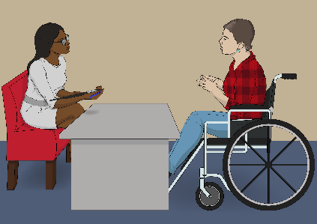
The team will also talk to people with learning disability in these services.

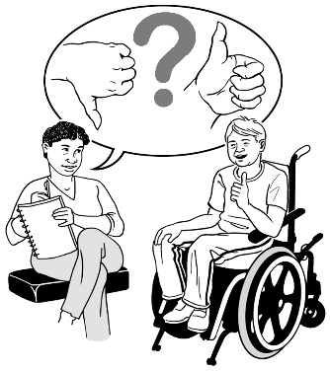
The team will ask them if they want their story to be looked at.

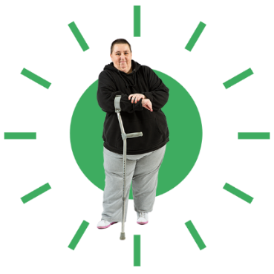
If the people say yes the team will ask the services for this information.

Who else will the team talk to?

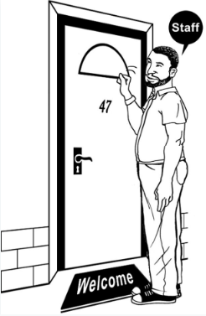
The team will also talk to District Inspectors.
District Inspectors are people who check on the High and Complex Framework services.
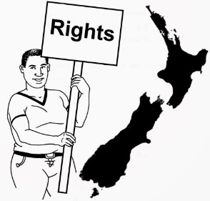
They make sure that people who live in the services get their rights.

The team will also talk to people who are not from the Ministry of Health who:
- know a lot about the High and Complex Framework
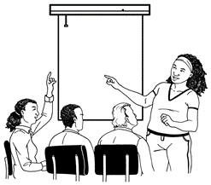
- know a lot about supporting people with learning disability.

How will the team tell people what they find out?

The team will write a draft report.

Draft means that there may be things they still need to change in the report.

They will give the draft report to the boss of the Ministry of Health.

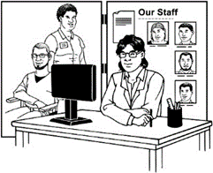
If the report says things about people who do not work at the Ministry of Health the team may show the draft report to those people too.
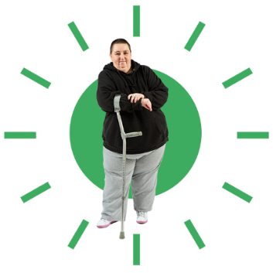
People whose information has been used for a case study will be shown the part of the report that is about them.

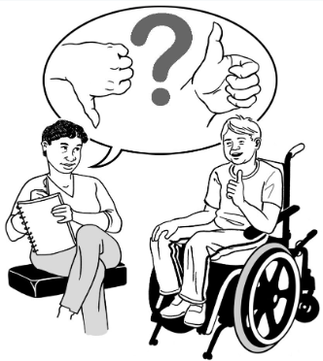
The people who have been shown the report can give feedback to the team if they are worried about parts of it.

Feedback is where people can say what they think about the report.
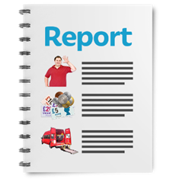
The team may put feedback about the draft report into the final report.

It is called the final report when there are no more changes to be made.

The final report will go to:
- the boss of the Ministry of Health
- the website of the Ombudsman where everyone can read it

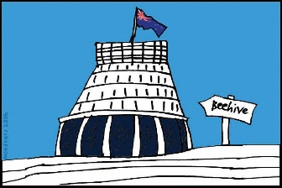
- Parliament for them to talk about.

Parliament is where the Prime Minister and other people who run the country work.
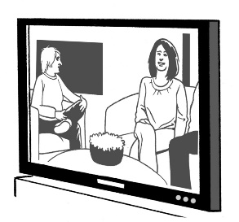
The report might be talked about on:
- TV and radio stations

- Newspapers

- news organisations on the internet.

What happens after the investigation?

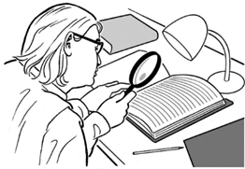
The Ombudsman will keep looking to see how the Ministry of Health is looking after services that are part of the High and Complex Framework.
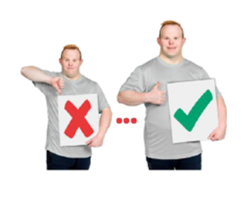
The Ombudsman will look to see if the Ministry of Health is making changes.

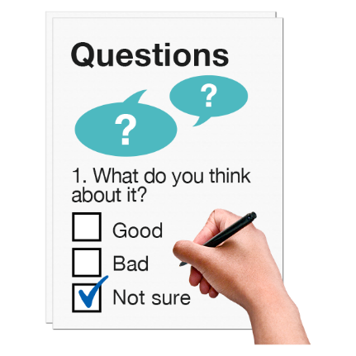
The Ombudsman will also ask the Ministry of Health:
- what did the team do well?

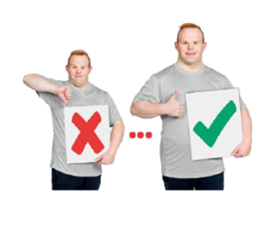
- what can the team do better next time?

- will this investigation help you work better in future?

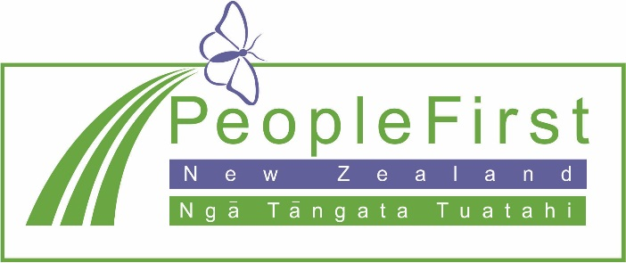

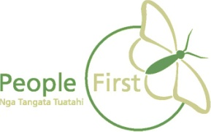
This information has been translated into Easy Read by the Make It Easy service of People First New Zealand Inc. Ngā Tāngata Tuatahi.

The ideas in this document are not the ideas of People First New Zealand Ngā Tāngata Tuatahi.
