A.3a

OPCAT Report
Report on an unannounced inspection of Puna Poipoi Forensic Rehabilitation Ward, Waikato Hospital, under the Crimes of Torture Act 1989
March 2020
Peter Boshier
Chief Ombudsman
National Preventive Mechanism

Report on an unannounced inspection of Puna Poipoi Forensic Rehabilitation Ward, Waikato Hospital, under the Crimes of Torture Act 1989
ISBN: 978-0-473-51680-2 (PDF)
Published March 2020
Office of the Ombudsman | Wellington, New Zealand | www.ombudsman.parliament.nz

Contents
Executive Summary 3
Background 3
Summary of findings 3
Recommendations 4
Feedback meeting 5
Consultation 5
District Health Board response 5
Facility Facts 6
Puna Poipoi Forensic Rehabilitation Ward 6
Region 6
District Health Board 6
Operating capacity 6
Last inspection 6
The Inspection 7
Inspection methodology 7
Inspection focus 8
Treatment 8
Protective measures 8
Material conditions 8
Activities and programmes 8
Communications 8
Health care 9
Staff 9
Evidence 9
Recommendations from previous report 9
Treatment 10
Torture or other cruel, inhuman or degrading treatment or punishment 10
Seclusion 10
Restraint 10
Restraint training for staff 10
Electro-convulsive therapy 11
Sensory modulation 11
Service user views on treatment 11
Recommendations – treatment 11
Protective measures 12
Complaints process 12
Records 12
Recommendations – protective measures 13
Puna Poipoi comments 13
Material conditions 14
Accommodation and sanitary conditions 14
Food 15
Recommendations – material conditions 16
Puna Poipoi comments 16
Activities and programmes 17
Outdoor exercise and leisure activities 17
Programmes 18
Cultural and spiritual support 18
Recommendations – activities and programmes 19
Puna Poipoi comments 19
Communications 20
Access to visitors 20
Access to external communication 20
Recommendations – communications 21
Puna Poipoi comments 21
Health care 22
Primary health care services 22
Recommendations – health care services 22
Staff 22
Staffing levels and staff retention 22
Recommendations – staff 23
Acknowledgements 24
Appendix 1. List of people who spoke with Inspectors 25
Appendix 2. Legislative framework 26

Tables
Table 1: List of people who spoke with Inspectors 25

Figures
Figure 1: Larger communal area 14
Figure 2: Quiet lounge 14
Figure 3: Bedroom 15
Figure 4: Shower 15
Figure 5: Secure courtyard 17
Figure 6: ‘Green room’ used for whānau visits and other meetings. 20

Executive Summary

Background
In 2007, the Ombudsmen were designated one of the National Preventive Mechanisms (NPMs) under the Crimes of Torture Act 1989 (COTA), with responsibility for examining and monitoring the conditions and treatment of service users detained in secure units within New Zealand hospitals.
Between 16 September and 18 September 2019, Inspectors — whom I have authorised to carry out visits to places of detention under COTA on my behalf — made an unannounced inspection of Puna Poipoi Forensic Rehabilitation Ward (the Ward), which is located within the grounds of Waiora Waikato Hospital campus, Hamilton.

Summary of findings
My findings are:
- Interactions between staff and service users were respectful, constructive and appropriate.
- Service users who spoke with Inspectors were positive about their experiences on the Ward.
- Files contained the necessary paperwork to detain and treat the patients in the Unit.
- Care plans were up-to-date, with evidence of regular reviews occurring.
- The Multi-Disciplinary Team (MDT) reviews for service users were thorough. Service users were included in the MDT review and offered a copy of their review documentation.
- The Ward was clean, tidy and well maintained.
- Generally, service users described the meals as adequate.
- There was evidence that service users regularly attend medical appointments, including dental appointments.
- Staff who spoke with Inspectors were positive about the leadership and management of the Ward and felt supported.
The issues that needed addressing are:
- There was no information on how to make a complaint or contact details for District Inspectors displayed on the Ward.
- Service users’ toiletries were locked away and accessible only on request.
- The Ward was not fit for purpose; bedrooms were small with inadequate storage and no ventilation, and there were insufficient numbers of showers and toilets for service users.
- Service users were unable to access hot drinks independent of staff, and were not able to eat and drink their own food on the Ward.
- There was no fresh air accessible to service users on the Ward other than in the courtyard, which was locked and could be accessed only with staff support and supervision.
- Service users had limited access to programmes and activities, minimal community engagement, and restricted outings.
- The visits room was not fit for purpose.
- Service users were unable to access the telephone independent of staff.

Recommendations
I recommend that:
- The complaints process, including complaint forms and contact details for the District Inspector, are well advertised and accessible to service users on the Ward.
- Service users are given their own toiletries, unless deemed unsafe for clinical reasons.
- The building is upgraded, including provision of sufficient showers and toilets for the number of service users.
- Service users are able to freely access hot drinks unless deemed unsafe based on individual risk assessment, and have their own food on the Ward at any time.
- All service users have unrestricted access to the Ward’s outdoor area during the day, unless deemed inappropriate for clinical reasons.
- Service users have increased access to activities and programmes, both on and off the Ward.
- The Ward provide a more suitable whānau visits room.
- Service users have access to a telephone, independent of staff, at any time unless deemed unsafe based on individual risk assessment.

Follow up inspections will be made at future dates to monitor implementation of my recommendations.

Feedback meeting
On completion of the inspection, my Inspectors met with representatives from the Ward’s leadership team, to outline their initial observations.

Consultation
A provisional report was forwarded to the DHB for comment as to fact, finding or omission prior to finalisation and distribution.

District Health Board response
The Waikato District Health Board (the DHB) provided a response to my provisional report on the Ward on 15 January 2020. I have carefully considered the comments made before finalising my report. Where the DHB has provided a specific response to my recommendations, this is recorded below each recommendation. Where necessary, I have responded with further comment.
The DHB’s report responded to a number of common themes from my inspections of this Ward and three other wards in the DHB which were conducted at the same time, including over occupancy, high and increasing use of seclusion and restraint, and the normalisation of restrictive practices.
The DHB emphasised planned changes or changes that had been made between the inspection in September 2019 and the DHB’s comments in January 2020. While I am pleased to hear that the DHB is taking steps to address a number of identified issues, my role as an NPM is to report on the conditions and treatment for people who are being detained, as they are at the time of the inspection. As such, while I acknowledge the further information provided by the DHB, my recommendations relate to the conditions and evidence my Inspectors found during the time of inspection.
I intend to conduct follow up inspections of all the wards, at which point I will be able to assess whether the actions highlighted by the DHB have been successful in addressing my concerns.

Facility Facts

Puna Poipoi Forensic Rehabilitation Ward
Puna Poipoi (the Ward) is an 11-bed forensic rehabilitation mental health ward in the Henry Rongomau Bennett Centre (HRBC), which is located in the grounds of Waiora Waikato Hospital, Hamilton.
The Ward primarily cares for male service users admitted from the courts and prison; also transfers and referrals from other forensic and adult mental health wards. The Puawai Midland Regional Forensic Service (the Service) at the HRBC is funded for four designated beds for service users with intellectual disabilities.

Region
Puawai Midland Regional Forensic Service – Waikato, Lakes, Taranaki and Bay of Plenty

District Health Board
Waikato District Health Board

Operating capacity
11

Last inspection
Unannounced Inspection - March 2013

The Inspection
Two Inspectors conducted the inspection of the Ward between 16 September and
18 September 2019.
On the first day of inspection, there were 11 service users in the Ward, all male. The average length of stay was 439 days, with the longest staying service user having been on the Ward for 1638 days (4.5 years). A number of service users had experienced multiple admissions.

Inspection methodology
At the beginning of the inspection, Inspectors met with the Charge Nurse Manager (CNM), before being shown around the Ward.
Inspectors were provided with the following information during and after the inspection:
- a list of service users and the legislative reference under which they were being detained (at the time of the inspection);
- the seclusion and restraint data for the period 1 March to 31 August 2019, and the seclusion and restraint policies;
- records of staff mandatory training, including restraint training;
- any meetings/reports relating to restraint, seclusion minimisation, and adverse events;
- service user absent without leave (AWOL) events for the period 1 March to 31 August 2019;
- details of all sentinel events for the period 1 March to 31 August 2019;
- information provided to service users and their whānau on admission;
- complaints received for the period 1 March to 31 August 2019, a sample of responses and associated timeframes, and a copy of the complaints policy;
- copy of minutes of consumer and service user group meetings for the period 1 June 2019 to 31 August 2019;
- activities programme;
- staff sickness and retention data for the previous three years;
- staff vacancies at time of inspection (role and number); and
- data on staff, categorised by profession.

Inspection focus
The following areas were examined to determine whether there had been torture or other cruel, inhuman or degrading treatment or punishment, or any other issues impacting adversely on service users.

Treatment
- Torture or other cruel, inhuman or degrading treatment or punishment
- Seclusion and de-escalation
- Seclusion policies and events
- Restraint
- Restraint training for staff
- Electro-convulsive therapy (ECT)
- Sensory modulation
- Service users’ views on treatment

Protective measures
- Complaints process
- Records

Material conditions
- Accommodation and sanitary conditions
- Food

Activities and programmes
- Outdoor exercise and leisure activities
- Programmes
- Cultural and spiritual support

Communications
- Access to visitors
- Access to external communications

Health care
- Primary health care services

Staff
- Staffing levels and staff retention

Evidence
In addition to the documentary evidence provided at the time of the inspection, Inspectors spoke with a number of managers, staff and service users.
Inspectors also reviewed service user records, were provided additional documents upon request by the staff, and observed the facilities and conditions.

Recommendations from previous report
There were no recommendations made by my predecessor, following an inspection of the Ward in 2013.

Treatment

Torture or other cruel, inhuman or degrading treatment or punishment
There was no evidence that any service user had been subject to torture or other cruel, inhuman or degrading treatment or punishment.

Seclusion

Seclusion facilities
The Ward did not have a seclusion facility. If service users required seclusion, they would be moved to a seclusion room in either Puna Maatai or Puna Awhi-rua.

Seclusion policies and events
A copy of the DHB’s Seclusion Procedure 1860 (dated 28 August 2017) was provided to Inspectors. The procedure had a review date of 28 August 2020.
There had been no incidents of seclusion for the period 1 March to 31 August 2019.

Restraint
The Service provided Inspectors with a copy of the DHB’s Restraint Policy 2162 (dated 10 March 2017). The policy was out-of-date and due for review on 1 July 2019.
There were no episodes of restraint recorded on Puna Poipoi for the period 1 March to 31 August 2019.

Restraint training for staff
Information provided by the Service showed that 34 of the 40 relevant staff were up-to-date with their Safe Practice Effective Communication (SPEC) training. Catch-up training was planned in the coming weeks.

Electro-convulsive therapy
There were no service users undergoing electro-convulsive therapy (ECT) in the Ward at the time of the inspection.

Sensory modulation
The Ward had no Sensory Modulation Room.

Service user views on treatment
Service users spoken with by the Inspectors were complimentary about the staff and management of the Ward. They understood their programmes, leave entitlements and visiting arrangements for friends and whānau.
Service users commented that the regime for access to toiletries was restrictive, and they were uncomfortable having to use their toiletries in the communal area.
Service users spoken with considered the food on the Ward to be adequate, but were disappointed they could not consume their own food and drinks on the Ward. Service users spoken to stated they were bored due to a lack of activities in the Ward, particularly in the afternoon and evening.
Inspectors observed staff interacting with service users in an engaging, respectful, and caring manner. Discussions about service users between Multi-Disciplinary Team (MDT) members were constructive and sought to identify positive treatment journeys and outcomes for service users. Service users said they generally felt safe in the Ward.
Inspectors observed one community meeting where staff and service users discussed both individual plans for the day and Ward activities. The interactions between staff and service users were respectful and constructive.

Recommendations – treatment
I have no recommendations to make.

Protective measures

Complaints process
A copy of the Service’s Consumer Feedback and Complaints Policy 0101 (dated 28 January 2019) was provided to Inspectors. The Policy had a review date of 18 January 2022.
There was no information about the complaints process, or complaint forms available on the Ward. The foyer displayed a poster about complaints and had forms available to make complaints there. However the complaints forms were not accessible to service users without staff support.
The Health and Disability Commissioner Code of Rights was displayed in the Ward.
Staff were familiar with the complaints process and were able to describe how to support service users and whānau to make a complaint. Staff informed Inspectors that complaint forms were given to service users on request.
Contact details for District Inspectors, were on display in the staff office but not on the Ward. Service users had to request staff contact the District Inspector on their behalf. Staff informed Inspectors that they facilitated these phone calls on request.
It is the statutory role of District Inspectors to hear service users’ complaints and of the facility to ensure that service users are informed of this. The steps that service users must go through to contact District Inspectors introduces an unacceptable risk that they may be prevented from exercising their right to make complaints about their treatment.
I therefore consider that it is insufficient for District Inspectors’ details to be accessible only on request; these details should be clearly visible on the Ward.
The Ward had received no complaints in the period 1 March to 31 August 2019.

Records
There were 11 service users on the Ward on the first day of inspection. Inspectors reviewed all service users’ detaining paperwork.
All files contained the necessary documentation authorising the detention (and treatment) of the service users in the Ward. Eight service users were detained under the Criminal Procedure (Mentally Impaired Persons) Act 2003 and three service users were detained under the Mental Health (Compulsory Assessment and Treatment) Act 1992.
One Inspector attended a Multi-Disciplinary Team (MDT) meeting and observed this to be comprehensive and well-documented. The service user was present at the MDT and was encouraged and supported to fully participate in the discussion. The service user was offered a written copy of their review.
From speaking with staff and service users and reviewing service user files, it was evident that the level of acuity in the Ward had led to a number of restrictive practices. For example, the locked courtyard, service users unable to access their own toiletries, food or drinks, and staff controlling service users’ access to the telephone. These issues are discussed later individually.

Recommendations – protective measures
I recommend that:
- The complaints process, including complaint forms and contact details for the District Inspector, are well advertised and accessible to service users on the Ward.

Puna Poipoi comments
The DHB partially accepted recommendation 1.
Recommendation 1 response:
A poster on the complaint process and complaint forms will be made available in the ward.
Providing the contact details of district inspectors on the wards would result in the following:
- It would not be clear as to which District Inspector is on duty
- The District Inspectors would receive calls about matters that are unrelated to the role of the District Inspector
The District Inspectors are always accessible by staff and will speak to service users put through by a staff member at any time.
Ombudsman response:
I acknowledge the DHB’s comments. However, I do not consider the reasons provided justify the restriction on access to District Inspectors’ contact information. Service users should be able to contact District Inspectors at any time, independent of staff.
There should be practical ways of mitigating the issues raised while also improving accessibility and visibility of the District Inspectors’ contact information. My Inspectors have observed several facilities where this information is displayed prominently without this proving to be problematic.

Material conditions

Accommodation and sanitary conditions
Ward communal areas were clean, tidy and well ordered.
The communal lounge, which doubled as a meeting area, contained couches, a pool table and a table tennis table. The room was a thoroughfare to get to the two bedroom wings, dining room and staff areas. Inspectors noted the room was crowded when all service users were on the Ward. There were two additional smaller quiet rooms on the Ward, one accessible through the other.
The only ventilation on the Ward was through doors opening out to the courtyard, which could only be opened by staff. Staff had to supervise service users in the courtyard.
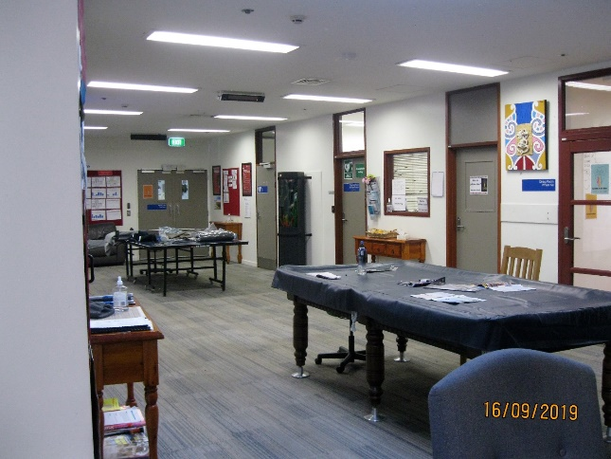 |  | 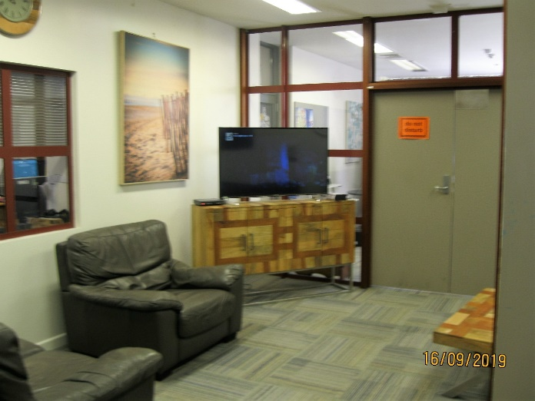
Figure 1: Larger communal area |  | Figure 2: Quiet lounge
There was a daily cleaning roster and an expectation that service users participate in daily chores after breakfast. During the inspection, Inspectors did not observe service users completing their chores or being encouraged to do so.
The Ward was dated and lacked sufficient space to allow service users time away from the busy communal area.
Both staff and service users told my Inspectors that the physical environment was not conducive to a therapeutic environment.
There were 11 bedrooms on the Ward. One bedroom had an en-suite shower and toilet. The remaining 10 bedrooms shared one shower room and two toilets; one toilet being in a shower room. Service users were unable to access their own toiletries unless supervised by a member of staff. Staff confirmed that toiletries were kept in a locked cupboard for safety purposes.
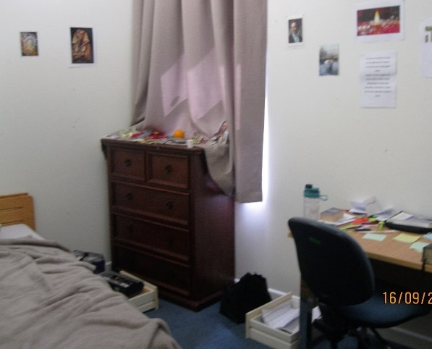 |  | 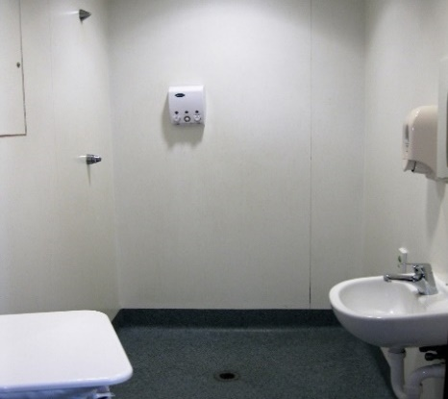
Figure 3: Bedroom |  | Figure 4: Shower
Bedrooms were small, with restricted natural light and no ventilation. Bedrooms lacked storage, with some service users storing their personal belongings in plastic tubs. Privacy curtains were installed across all observation windows and service users were able to lock their bedroom doors. Service users were discouraged from spending time in their bedrooms during the day.
Service users had unrestricted access to clean bedding, and laundry facilities were accessible with staff support. The standard of hygiene in some of the bedrooms was poor, with evidence that sheets had not been changed for some considerable time.
It is my view that the building is no longer fit for purpose.

Food
Meals were prepared in the hospital kitchen and transported to the Ward in a trolley. All service users were required to eat their meals in the dining room.
Service users could choose their meals from a daily menu and dietary requirements were provided for. Inspectors observed a lunch meal and the quality and quantity of the food appeared satisfactory. Service users my Inspectors spoke with did not particularly enjoy the meals but considered them to be adequate.
Breakfast took place from 7.30 to 7.45am, lunch at 12pm and the evening meal from 5pm. Service users had access to a water cooler at all times and could be provided with a hot drink on request. Fruit was freely available throughout the day. All meals were served in the dining area. Staff counted cutlery in and out to manage a risk presented by one service user.
Outside of meal times, the dining area was locked. Service users were unable to access the kitchen area to make their own hot drinks during the day. Fruit was available throughout the day in the communal lounge. Service users could participate in a baking roster if they chose to. The Ward had recently had a hāngī.
Service users with leave were not permitted to bring their own food back on to the Ward. They had the option to eat their own food and snacks in the ‘green room’ in the foyer outside the Ward, or off site prior to returning to the Ward.

Recommendations – material conditions
I recommend that:
- Service users are given their own toiletries, unless deemed unsafe for clinical reasons.
- The building is upgraded, including provision of sufficient showers and toilets for the number of service users.
- Service users are able to freely access hot drinks, unless deemed unsafe based on individual risk assessment, and have their own food on the Ward at any time.

Puna Poipoi comments
The DHB accepted recommendation 3.
The DHB rejected recommendation 2, and an earlier iteration of recommendation 4.
Recommendation 2 response:
Service users currently have full accessibility to their toiletries other than razors and aerosol deodorants for safety purposes. Some toiletries are stored in a locked cupboard as a supply cupboard only.
Ombudsman response:
My Inspectors were informed by staff and service users that all toiletries were locked away. Inspectors observed staff handing out toiletries to service users. I consider that access to all toiletries should be facilitated based on individual risk and subject to regular review.
Recommendation 3 response:
Nothing can currently be done within the floor plan for the ward without decreasing the bed spaces however the Response Report provides details on planned changes to facilities.
Ombudsman response:
It is pleasing to hear that there are plans in place to change the facilities. I remain of the view that there are insufficient numbers of showers and toilets for the number of service users and this needs addressing prior to the planned changes.

Recommendation 4 response:
There is a safety aspect of care for both service users and staff. The potential for injury through hot drinks being thrown is a risk within the forensic area of practice. They are however regularly provided and can be made when requested.
Ombudsman response:
I acknowledge the safety concerns. However, it is not clear to me why a hot drink made by a staff member is less likely to cause injury than one made by the service user. My Inspectors’ observations are that there is not a consistent response to this issue across all facilities. The current policy on the Ward disadvantaged all service users as it applied to everyone irrespective of safety risk. I consider that free access to hot drinks should be available for all service users unless deemed unsafe based on individual risk assessment. I have adjusted my recommendation accordingly.

Activities and programmes

Outdoor exercise and leisure activities
The Service provided Inspectors with a copy of the Service’s Courtyards Procedures 0516 (dated 22 February 2019). The Procedure had a review date of 22 February 2020.
The Ward had a secure outdoor area with seating, a small garden and a basketball hoop available for service users. However, the outdoor area could only be accessed when staff were available to supervise. This resulted in service users having restricted access to outdoor exercise and fresh air. The furniture was secured to the ground to prevent it from being moved and used to abscond over the courtyard fence. The gardens were overgrown and in need of attention. The doors to the courtyard were observed to be open once during the inspection.
There was a fully equipped gym on site accessible to service users. A personal trainer scheduled sessions with service users at the onsite gym, or at the local YMCA. The Ward had a ‘quiet lounge’ in which service users could listen to music, or access the Ward computer. There was also one piece of exercise equipment in the lounge.  In the adjacent lounge was a TV to enable service users to watch TV outside of the large communal area. |  | 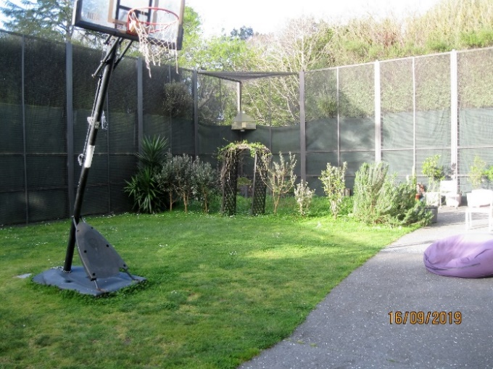
 |  | Figure 5: Secure courtyard
Service users with leave could go off the Ward with the required numbers of staff. Outings were primarily to the local shops and within hospital grounds.

Programmes
The Ward shared 1.5 full-time equivalent (FTE) Occupational Therapists with the adjacent ward. The Ward also had a FTE Activities Officer. The Psychologists, and Alcohol and Drug Counsellor also ran programmes and one to one sessions for service users on the Ward.
My Inspectors viewed a one-week sample of programmes, and noted they were limited.
Service users expressed a degree of boredom, particularly in the afternoon and evening, due to the lack of programmes available to them. Inspectors observed service users sleeping in communal areas during the day.
Ward community meetings were held on the Ward each morning Monday to Friday. These meetings were not minuted. Planned activities for the day were discussed for both individuals and the Ward.

Cultural and spiritual support
There were two Kaitakawaenga who provided cultural support to service users across the Service. Kaitakawaenga offered individual and group sessions to tangata whaiora. Group sessions were by invitation, with staff identifying who would benefit most from the specific group.
Chaplains attended the Ward on request and on occasion when passing. One service user attended the Mormon Church and received visits on the Ward from members of the Mormon Church. Another service user attended the hospital chapel.

Recommendations – activities and programmes
I recommend that:
- All service users have unrestricted access to the Ward’s outdoor area during the day, unless deemed inappropriate for clinical reasons.
- Service users have increased access to activities and programmes, both on and off the Ward.

Puna Poipoi comments
The DHB partially accepted recommendation 5.
The DHB rejected recommendation 6.
Recommendation 5 response:
Unrestricted access to the courtyard has in the past resulted in an increase in Absences without Leave over the fence. The area will work to increase the amount of time the courtyard is open within safety parameters. Most, if not all, service users have access into the community which happens every day, including walking to the local YMCA gym.
Ombudsman response:
I am pleased to learn that there will be work to increase the amount of time the courtyard is open. I also acknowledge the statement regarding safety considerations. However, the current policy disadvantaged all service users as it applied to everyone, irrespective of safety risk. I consider that access to the courtyard should be facilitated based on individual risk and subject to regular review.
Recommendation 6 response:
The forensic service has a therapeutic programme in place which is developed by the therapeutic coordinator...
In addition there are activities provided on the wards for clients to participate in if they choose.
Ombudsman response:
I acknowledge that a therapeutic programme is in place and that activities are provided for. My Inspectors were provided with comprehensive information on the therapeutic programme during the inspection and its contents had been taken into account in making my recommendation. I remain of the view that service users should have increased access to activities and programmes.

Communications

Access to visitors
Visits to Puna Poipoi were by appointment, with 24 hours’ notice. Visiting hours were Monday to Friday 4pm to 7:45pm, unless visitors were from out of town; weekends and public holidays from 10am to 11:45am, 1pm to 4pm and 6pm to 7:45pm. Staff generally preferred for visits to take place after 3pm to suit the day-to-day operation of the Ward, however, visiting times could be flexible.
Visits took place in the ‘green room’, which was adjacent to the Ward foyer. The room had no natural light, no comfortable chairs and was not suitable for accommodating whānau or other social visits.  If the service user had Ward leave, the visit could be facilitated off site or in the lounge on the adjacent open Ward. A member of staff supervised visits.  No visits took place on the Ward. |  | 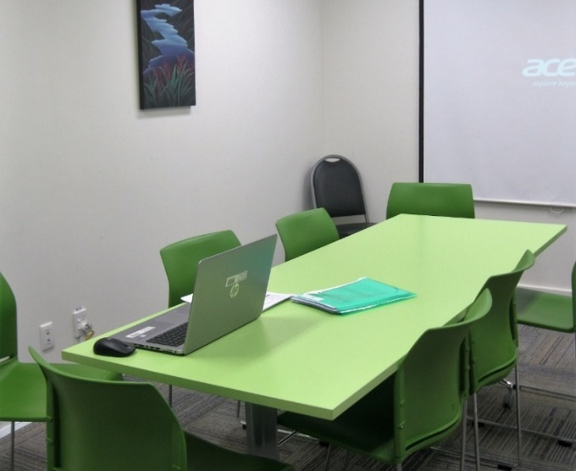
 |  | Figure 6: ‘Green room’ used for whānau visits and other meetings.

Access to external communication
Service users were able to access a telephone on request between 6pm and 9pm, or by negotiation. Service users were restricted to two personal calls per day, and could have two failed attempts to make each telephone call. Calls for legal purposes were able to be made in addition to this at any time of day, on request. Service users could make telephone calls in the quiet lounge, although they were supervised by staff.

Recommendations – communications
I recommend that:
- The Ward provide a more suitable whānau visits room.
- Service users have access to a telephone, independent of staff, at any time unless deemed unsafe based on individual risk assessment.

Puna Poipoi comments
The DHB rejected recommendations 7, and an earlier iteration of recommendation 8.
Recommendation 7 response:
This is a multipurpose room, used at times for whānau visits. There are no alternatives within the current secure environment. It is encouraged that facilitation of whānau visits occurs off site whenever possible.

Ombudsman response:
I remain of the opinion that this room is not a suitable environment to encourage whānau connections and is not fit for purpose.
Recommendation 8 response:
As service users progress through the forensic rehabilitation pathway access to phones is implemented as part of their recovery pathway.
Ombudsman response:
I acknowledge that access to telephones is increased as part of service users’ recovery pathway. However I remain of the view that all users should have access to a telephone, independent of staff, at any time unless there are individual safety concerns or a Court order precluding such access. I have adjusted my recommendation accordingly.

Health care

Primary health care services
There was evidence that service users had access to a range of medical services, with appointments for dental, physiotherapy and other medical appointments recorded on file. I have no concerns in relation to the provision of healthcare to service users.
Initial health assessments were carried out on admission, usually in Puna Maatai or
Puna Awhi-rua Wards.
A treatment room was available on the Ward for physical examinations. Medications were also stored in this room. There were no controlled drugs stored on the Ward. The treatment room was tidy and well organised.

Recommendations – health care services
I have no recommendations to make.

Staff

Staffing levels and staff retention
There was a good mix of age, gender, ethnicity and experience among staff.
Staff worked to a three-shift roster with a designated staffing level. The morning shift was from 7am to 4pm, with four or five Registered Nurses (RN) and two or three Psychiatric Assistants (PA). The afternoon shift was from 3pm to 11.30pm, with two or three RNs and two or three PAs. The night shift was from 11pm to 7.30am with one RN and two PAs.
The Ward had recently had four RNs resign. Data provided by the Service indicated that there had been no turnover of RNs in 2018/2019 prior to these four resignations, compared to a turnover of 12.5 percent the previous year. Data for turnover of PA staff for the 2018/2019 year was requested, but not provided.
Staff sickness rates reported for the 2018/2019 year were low for RNs at 1.5 percent, however there was a sickness rate of 12.8 percent for PA staff in this period.
There was an annual mandatory training schedule for staff throughout the Service.
Over the course of the inspection, Inspectors observed staff spend the majority of their time actively on the Ward with service users.

Recommendations – staff
I have no recommendations to make.

Acknowledgements
I appreciate the full co-operation extended by the Charge Nurse Manager and staff to the Inspectors during their inspection of the Ward. I also acknowledge the work involved in collating the information requested.

Peter Boshier
Chief Ombudsman
National Preventive Mechanism
- List of people who spoke with Inspectors
Table 1: List of people who spoke with Inspectors
Managers | Ward staff | Others
Operations Manager  Director Area Mental Health | Charge Nurse Manager  Clinical Nurse Specialist  Registered Nurses  Occupational Therapist  Activities Officer  Psychiatric Assistants  Security staff | Service Users  District Inspector  Cultural Advisor  Alcohol and Drug Counsellor

- Legislative framework
In 2007 the New Zealand Government ratified the United Nations Optional Protocol to the Convention against Torture and Other Cruel, Inhuman or Degrading Treatment or Punishment (OPCAT).
The objective of OPCAT is to establish a system of regular visits undertaken by an independent national body to places where people are deprived of their liberty, in order to prevent torture and other cruel, inhuman or degrading treatment or punishment.
The Crimes of Torture Act 1989 (COTA) was amended by the Crimes of Torture Amendment Act 2006 to enable New Zealand to meet its international obligations under OPCAT.

Places of detention – health and disability facilities
Section 16 of COTA defines a “place of detention” as:
“…any place in New Zealand where persons are or may be deprived of liberty, including, for example, detention or custody in…
(d) a hospital
(e) a secure facility as defined in section 9(2) of the Intellectual Disability (Compulsory Care and Rehabilitation) Act 2003…”
Pursuant to section 26 of COTA, an Ombudsman holding office under the Ombudsmen Act 1975 (Ombudsmen Act) was designated a National Preventive Mechanism (NPM) for certain places of detention, including hospitals and the secure facilities identified above.
The New Zealand Gazette of 6 June 2018 sets out in further detail the relevant places of detention:
“…in health and disability places of detention including within privately run aged care facilities; …”

Carrying out the NPM’s functions
Under section 27 of COTA, an NPM’s functions, in respect of places of detention, include:
- to examine the conditions of detention applying to detainees and the treatment of detainees; and
  - to make any recommendations it considers appropriate to the person in charge of a place of detention:
  - for improving the conditions of detention applying to detainees;
  - for improving the treatment of detainees; and
  - for preventing torture and other cruel, inhuman or degrading treatment or punishment in places of detention.
Under sections 28 – 30 of COTA, NPMs are entitled to:
- access all information regarding the number of detainees, the treatment of detainees and the conditions of detention;
- unrestricted access to any place of detention for which they are designated, and unrestricted access to any person in that place;
- interview any person, without witnesses, either personally or through an interpreter; and
- choose the designated places they want to visit and the people they want to interview.
Section 34 of the COTA, confers the same powers on NPMs that NPMs have under any other legislation when carrying out their function as an NPM. These powers include those given by the Ombudsmen Act to:
- require the production of any information, documents, papers or things that, in the Ombudsmen’s opinion, relates to the matter that is being investigated, even where there may be a statutory obligation of secrecy or non-disclosure (refer sections 19(1), 19(3) and 19(4) of the Ombudsmen Act); and
- at any time enter and inspect any premises occupied by any departments or organisation listed in Schedule 1 of the Ombudsmen Act (refer section 27(1) of the Ombudsmen Act).
To facilitate the exercise of the NPM function, the Chief Ombudsman has authorised inspectors to exercise the powers given to him as an NPM under COTA, which includes those powers in the Ombudsmen Act for the purpose of carrying out the NPM function.

More information
Find out more about the Chief Ombudsman’s NPM function, inspection powers, and read his reports online: www.ombudsman.govt.nz under What we do > Protecting your rights > Monitoring places of detention.

When the term Inspectors is used, this refers to the inspection team comprising two Senior Inspectors.
The wards inspected at the same time were Wards 34, 35 and 36, Puna Awhi-rua and Puna Maatai.
Student Nurse Welcome Pack Puna Poipoi.
The forensic service includes Puna Maatai, Puna Awhi-rua, and Puna Poipoi.
Sentinel events are unanticipated events in the healthcare setting which have generally resulted in serious harm to service users.
My inspection methodology is informed by the Association for the Prevention of Torture’s Practical Guide to Monitoring Places of Detention (2004) Geneva, available at www.apt.ch.
For a list of people spoken with by the Inspectors, see Appendix 1.
OPCAT report on an unannounced inspection of Waikato District Health Board’s Ward 31 (Puna Poipoi) Under the Crimes of Torture Act 1989, June 2013.
‘Seclusion’ is defined as: ‘Where a person is placed alone in a room or area, at any time and for any duration, from which they cannot freely exit’. New Zealand Standards. Health and Disability Services (Restraint Minimisation and Safe Practice) Standards. Ministry of Health. 2008.
SPEC training was designed to support staff working within inpatient mental health wards to reduce the incidence of restraints. SPEC training has a strong emphasis on prevention and therapeutic communication skills and strategies, alongside the provision of training in safe, and pain free personal restraint techniques. https://www.tepou.co.nz/initiatives/towards-restraint-free-mental-health-practice/149
Electroconvulsive therapy is used mainly in the treatment of severe depressive episodes. It involves the passage of an electric current across the head of a person to produce a convulsion. https://www.health.govt.nz/publication/electroconvulsive-therapy-ect
Waikato DHB’s Sensory Modulation Procedure 3248 (dated 28 Jan 2019): A therapeutic environment specifically designed to promote self-organisation and positive change. Sensory modulation rooms can be used for de-escalation and for identifying new skills and preferences that can be transferred to other environments.
Mental Health (Compulsory Assessment and Treatment) Act 1992, sections 64(2)(g). The functions and powers of Dis are located in sections 94 to 98 of the Act.
Service users are able to freely access hot drinks and have their own food on the Ward at any time.
Puna Taunaki, an open rehabilitation Ward.
Designated person (Māori) who offers advocacy and cultural support to service users and their whānau.
Service users have access to a telephone, independent of staff, at any time.

